Phenylalanine ammonia lyase: new insights from Piperaceae species

Andreia de Araújo Morandim-Giannetti¹, Lidiane Gaspareto Felippe², Vânia Aparecida de Freitas Formenton Macedo dos Santos², Massuo Jorge Kato³, Maysa Furlan²⁺

1. FEI University Center, Department of Chemical Engeneering, São Bernardo do Campo, Brazil.
2. Paulista State University, Institute of Chemistry, Araraquara, Brazil.
3. University of São Paulo, Institute of Chemistry, São Paulo, Brazil.

+Corresponding author: Maysa Furlan, Phone: +551633019500, Email address: maysa.furlan@unesp.br

ARTICLE INFO

Article history:
Received: October 19, 2021
Accepted: February 22, 2022
Published: August 17, 2022

Section Editor: Assis Vicente Benedetti

Keywords
1. Peperomia
2. Piper
3. phenylalanine ammonia lyase
4. phenylpropanoid derivatives
5. Thermal stability

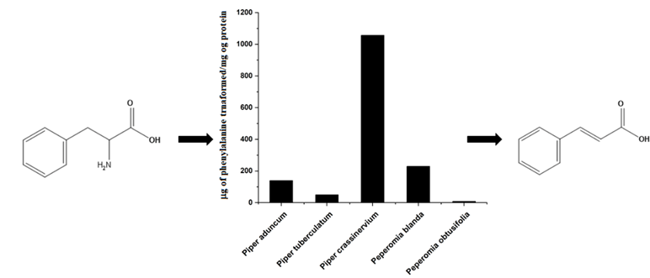
ABSTRACT: The enzyme PAL (phenylalanine ammonia lyase) mediates the key entry point to the general phenylpropanoid pathway, which is involved in the lignification process and in the formation of a myriad of secondary compounds in plants that show a variety of biological activities. Soluble fractions containing PAL extracted from Piper and Peperomia species had the optimal catalytic activity analyzed by statistical design model. This analysis revealed that the best conversion of L-phenylalanine to trans-cinnamic acid was pH 9.3 and 58 °C after 25 h, corroborating interesting thermal stability. Additionally, the pre-purification of PAL using ammonium sulfate precipitation (25-55%) increased its specific activity, approximately 133% in P. aduncum and more than 900% in P. crassinervium. The content of lignin was higher for
P. tuberculatum (25.71%), while only a small amount of lignin was observed in Peperomia blanda (11.95%). It is interesting to note that Peperomia plants are succulent and without significant amounts of lignin. However, the phenylpropanoid biosynthetic pathway is apparently addressed to produce predominantly tetrahydrofuran lignans with biological interest.

1. Introduction

Phenylalanine ammonia lyase (PAL, EC 4.3.1.24) (Toscano et al., 2018) plays a crucial role at the interface between primary and secondary metabolism in plants - it catalyzes the trans-deamination of L-phenylalanine to trans-cinnamic acid, which is the first step in the general phenylpropanoid pathway (Huang et al., 2020; Levy et al., 2018; Machado et al., 2013). This enzyme has an important role in plant growth since it is required to produce the macromolecule lignin in plants, which has a primary structural function and acts as physical and chemical barriers against pathogens (Gutiérrez-Quequezana et al., 2020; Vanholme et al., 2019; You et al., 2020).
The phenylpropanoid pathway, one of the most important secondary metabolism pathways, leads to the biosynthesis of a wide range of secondary metabolites, such as flavonoids, isoflavonoids, anthocyanins (Dong et al., 2016; Mota et al., 2011; Prabpree et al., 2018), phenylalanine derivatives (Batista Junior et al., 2009; 2010; Batista et al., 2012; Felippe et al., 2012; Moraes and Kato, 2021; Ramos et al., 2013; Yoshida et al., 2018; You et al., 2020), phytoalexins (Dong et al., 2016), chromenes (Batista et al., 2017; Kitamura et al., 2006; Lago et al., 2004; Morandim et al., 2005; Salazar et al., 2005; Souza et al., 2019), chromanes (Batista Junior et al., 2012; El Babili et al., 2021), amides (García-Huertas et al., 2018; Lopes et al., 2007; López et al., 2010; Mota et al., 2009), monolignols (Macêdo et al., 2020), coumarins (Banu et al., 2019), and lignans (Dong et al., 2016) (Fig. 1).

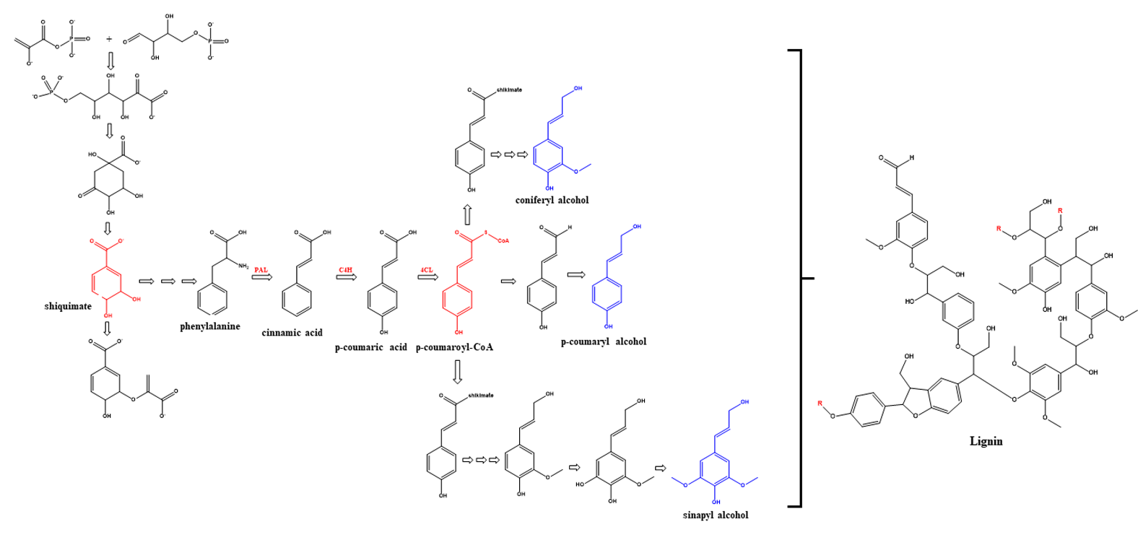
Figure 1. Phenylpropanoid pathways involved in the formation of lignin.
Source: Adapted from Vanholme et al. (2019).

In the lignin pathway, three principal enzymes are involved: phenylalanine ammonia lyase (PAL), cinnamate 4-hydroxylase, and 4-coumarate: CoA ligase (Banu et al., 2019; Vanholme et al., 2019). In the lignin biosynthesis in plants, PAL is the primer enzyme that mediates the formation of the cinnamic acid, which is the first product in the general phenylpropanoid pathway (Dong et al., 2016; Felippe et al., 2012; Klejdus et al., 2013; Machado et al., 2013). A series of enzymes are required to produce the cinnamyl alcohols required for the radical reaction: hydroxycinnamoyl CoA:shikimate hydroxycinnamoyl transferase, hydroxycinnamoyl CoA:quinate hydroxycinnamoyl transferase, p-coumaroyl shikimate 3’-hydroxylase, and ferulate (coniferaldehyde) 5-hydroxylase (Kamdee et al., 2014). These units are mainly oxidized by the action of peroxidases and laccases. Subsequently, the lignin phenoxyl radicals react to form lignin (A. Silva et al., 2019a; Veronico et al., 2018; Weiss et al., 2020).
In this context, in the plant biomass, lignin (whose content depends on plant species and tissues) is associated with cellulose and hemicellulose and prevents biological degradation of these materials, as well as providing mechanical support for plant tissues. Therefore, lignin confers strength and rigidity to the cellulose fiber’s assembly (Gao et al., 2019). After cellulose, lignin is the second most abundant organic compound in plants, representing approximately 30% of the organic carbon in the biosphere (Kamdee et al., 2014). From a functional point of view, lignin imparts strength to cell walls, facilitates water transport, and prevents degradation of wall polysaccharides, thereby acting as a major defense line against pathogens, insects, and other herbivores (Tronchet et al., 2010).
However, the genetic manipulation of the enzymatic routes, e.g., the PAL enzyme production, may favor the optimization of the separation of lignin from the cellulose pulp. This causes a reduction in the cost and pollution during the lignocellulosic processes, once the lignification is controlled by many enzymes including PAL (Hamedan et al., 2019; Liu et al., 2019; Toscano et al., 2018). Therefore, by reducing the PAL activity, it is possible to minimize the lignin content resulting in weak stem physical strength (Hussain et al., 2019).
This enzyme is mainly responsible for the biosynthesis of many activity compounds. Previous studies showed that these classes of secondary metabolites are among the most potent biologically active compounds found in Piper and Peperomia species, mainly species of the Piperaceae (Alves et al., 2019; Kato and Furlan, 2007). Species of this family present the following activities: antioxidant (Regasini et al., 2008; J. Silva et al., 2011; N. Silva et al., 2019b; Yamaguchi et al., 2006), anxiolytic, antiplatelet (Sant’Ana et al., 2020), antitumoral (Cortez et al., 2017; H. Silva et al., 2018), cytotoxic (Ferreira et al., 2014; Freitas et al., 2014; Maleck et al., 2014), trypanocidal (Batista Junior et al., 2008; Felippe et al., 2008; García-Huertas et al., 2018; Martins et al., 2003; Mota et al., 2009; Regasini et al., 2009), hypertension (Durant-Archibold et al., 2018), leishmanicidal (Araújo-Vilges et al., 2017; Macêdo et al., 2020; Neves et al., 2019; Oliveira et al., 2012; M. Silva et al., 2021), insecticidal, antifungal, bactericidal, acaricidal, molluscicidal (Corral et al., 2018; Danelutte et al., 2003; Ferreira et al., 2014; Lago et al., 2004; 2007; Marques et al., 2010; Miranda et al., 2003; Navickiene et al., 2000; 2003; Ramos et al., 2020; Reigada et al., 2007; Santos et al., 2013; R. Silva et al., 2002), anti-inflammatory (Arunachalam et al., 2020), larvicidal (Mgbeahuruike et al., 2017; Pereira Filho et al., 2021; Pinheiro et al., 2011; N. Silva et al.,
2019b), antiherbivore (Jeffrey et al., 2014), and antimalarial (Campelo et al., 2018; Moraes et al., 2013; H. Silva et al., 2018). Additionally, studies on the applications of the PAL enzyme have reported its use to treat diseases, such as phenylketonuria (Burton et al., 2020; Hartnett et al., 2013; Levy et al., 2018). This disease is a genetic mutation that inactivates the phenylalanine-4-hydroxylase (Burton et al., 2020; Levy et al., 2018; Sarkissian et al., 2011; Vogel et al., 2013), resulting in augmented levels of L-phenylalanine in the bloodstream by the inability to metabolize L-phenylalanine. In excess, phenylalanine itself shows a neurotoxic effect. The lack of treatment at birth leads to severe and irreversible mental retardation (Donlon et al., 2004). Therefore, PAL has gained considerable significance in several clinical and industrial applications in the past three decades. In the clinical field, physicians have used PAL to determine the serum level of L-phenylalanine, monitoring patients with phenylketonuria (Burton et al., 2020; Watanabe et al., 1992) and then to prepare low phenylalanine diets. Enzyme substitution therapy with a recombinant form of PAL successfully converts the excess L-phenylalanine into harmless metabolites, trans-cinnamic acid, and ammonia, which can be excreted in the urine (Rocha et al., 2021).
A major industrial application of PAL concerns the production of L-phenylalanine from trans-cinnamic acid by reversing the physiological reaction (Burton et al., 2020; Hamilton et al., 1985). The increasing demand for L-phenylalanine as a precursor of aspartame, a non-calorific sweetener (L-phenylalanyl-L-aspartyl methyl ester), has resulted in an industrial enzymatic process based on Rhodotorula cells immobilized in vermiculite, developed by Genex Corporation in the UK (Choudhary and Lee, 2018; Finkelman and Yang, 1985).
Herein, the results of the expression of PAL in leaves of five Piperaceae species are reported. The results provide insights into the PAL catalytic activities in these species, which are rich sources of the bioactive phenylpropanoid derivatives and open new opportunities to enhance the production of such class of metabolites. Furthermore, this study also provides relevant results about the activity effect on its concentration, which represents new opportunities for the industrial and agricultural applications, especially favored by its thermal stability.
2. Experimental

2.1 Plant material

Leaves of Piper aduncum L. and Peperomia obtusifolia (L.) A. Dietr. were collected at the Institute of Chemistry – UNESP, Araraquara–SP, Brazil (-21.806602382914665, -48.19284372352492). These specimens were identified by Dr. I. Cordeiro (Institute of Botany, SP). The voucher specimens (Cordeiro-PA0 and Kato-070) were deposited in the Herbarium at the Institute of Biosciences – USP, São Paulo-SP, Brazil.
Leaves of Piper tuberculatum Jacq. and Piper crassinervium Kunth were collected at the Institute of Chemistry - UNESP), Araraquara-SP, Brazil (-21.806602382914665, -48.19284372352492), and identified by Dr. G. E. D. Paredes (Universidad Nacional Pedro Ruiz Gallo, Peru). The voucher specimens (Kato-163 and Kato-0084) were deposited in the Herbarium at the Institute of Botany, São Paulo–SP, Brazil. Leaves of Peperomia blanda (Jacq.) were collected at Reserva da Ripasa, Ibaté–SP, Brazil (-22.237934727962543, -47.81789620915089) and identiﬁed by Dr. Elsie Franklin Guimarães (JBRJ). The voucher specimen (Kato-547) was deposited in the Herbarium at the Institute of Biosciences, USP, São Paulo–SP, Brazil.

2.2 Reagents and standards

Methanol (HPLC-grade) was purchased from Mallinckrodt (Baker, Xalostoc, Mexico); ascorbic acid, ethylenediamine tetraacetic acid (EDTA), sucrose, polyvinylpolypyrrolidone (PVPP), dithiothreitol (DTT), L-phenylalanine, cinnamic acid, boric acid, sodium borate, hydrochloric acid (HCl), and ammonium sulfate were acquired from Sigma-Aldrich (St. Louis, MO, USA). Nanopure water (> 18 MΩ cm) was produced using a Millipore (Bedford, MA, USA) purifier.

2.3 Enzyme Extraction

Fresh leaves of Piper aduncum, P. tuberculatum, P. crassinervium, as well Peperomia blanda and P. obtusifolia (25 g) were ground separately using liquid nitrogen. Then, 100 mL of borate buffer 0.1 M (pH 8.8) containing PVPP (10% w/w), sucrose (0.25 M), ascorbic acid (40 mM), EDTA (1 mM), and DTT (5 mM) were added. The suspensions were stirred for 15 min at 0 °C, filtered through cheesecloth, and centrifuged for 20 min at 4 °C and 11,950 g.
2.4 Enzymatic assay

The enzymatic assays were carried out by adding 250 µL of borate buffer 0.1 M, 125 µL of enzyme solution (0.2 mg/mL), and 150 µL of L-phenylalanine (10 mM) to Eppendorf tubes. The times (1, 6, 13, 20, and 25 h), temperatures (28, 35, 45, 55, and 62 ºC) and pH values (7.8, 8.2, 8.8, 9.4, and 9.8) were modified as suggested by the statistical design to optimize the process (Tab. 1). All the reactions were performed under agitation and terminated by adding 25 µL of HCl (6 M), in duplicate assays (Toscano et al., 2018). The solutions were stirred, neutralized, and then centrifugated at 7,000 g for 1 min, and the supernatants were analyzed by HPLC.

Table 1. Experimental conditions used to optimize the activity of the PAL (coded and non-coded variables).
Coded variables |  |  | Non-coded variables
Time (min) | pH | T (ºC) | Time (min) | pH | T (ºC)
+1 | -1 | +1 | 20 | 8.20 | 55
+1 | +1 | +1 | 20 | 9.40 | 55
0 | 0 | 0 | 13 | 8.80 | 45
0 | +$\sqrt{3}$ | 0 | 13 | 9.80 | 45
0 | 0 | +$\sqrt{3}$ | 13 | 8.80 | 62
-$\sqrt{3}$ | 0 | 0 | 1 | 8.80 | 45
0 | -$\sqrt{3}$ | 0 | 13 | 7.80 | 45
+1 | -1 | -1 | 20 | 8.20 | 35
-1 | +1 | -1 | 6 | 9.40 | 35
0 | 0 | -$\sqrt{3}$ | 13 | 8.80 | 28
-1 | -1 | -1 | 6 | 8.20 | 35
-1 | -1 | +1 | 6 | 8.20 | 55
+1 | +1 | -1 | 20 | 9.40 | 35
-1 | +1 | +1 | 6 | 9.40 | 55
+$\sqrt{3}$ | 0 | 0 | 25 | 8.80 | 45
0 | 0 | 0 | 13 | 8.80 | 45

HPLC analyses were conducted on a Shimadzu pump model LC-6AD, with an SPD-M20A diode array ultraviolet detector (HPLC-DAD), SIL-10AF automatic injector, and CBM-20A controller. Separation was achieved on a Phenomenex C₁₈ reverse-phase column (25 cm × 4.6 mm, 5 μm) in the isocratic mode, using MeOH/H₂O (1:1, with 0.1% HOAc) at a flow of 1.0 mL min^{–1} as the mobile phase. The formation of trans-cinnamic acid was monitored at a wavelength of 275 nm.
A standard RSM (Response Surface Methodology) design, known as CCRD (Central Composite Rotational Design), was used to model and analyze the data. The Analysis of Variance (ANOVA) using the Statistic Program 12.0 (StatSoft Inc., 2014, Oklahoma, USA) was used to process the results. The significance of the main factors and their interactions were assessed by the F-test method with a confidence level of 95%. The response surface methodology and a mathematical–statistical tool were employed to model the L-phenylalanine conversion to trans-cinnamic acid using the temperature, pH, and reaction time as variables. The Response desirability profiling option, which is given by the geometric mean of all individual desirability (Eq. 1), was applied to determine the optimum reaction condition for the PAL enzyme.

$D= \sqrt[m]{d_{1}d_{2}…..d_{m}}$ (1)

where, d describes the individual desirability and m the number of parameters analyzed.

The results of each CCRD were analyzed with the aid of the Statistic Program Software. The data was fitted to a second-order polynomial equation (Eq. 2).

Y=βo +∑β_{j}x_{j} +∑β_{jj}x_{j}² +∑β_{jk}x_{j}x_{k} (2)

2.5 Enzyme pre-purification

After determining the optimal reaction condition, new enzymatic extracts were obtained from the same plant species using the experimental procedures described above. In this case, 100 g of plant material and 400 mL of buffer were used. The protein extracts containing PAL were fractionated by ammonium sulfate saturation at 0-25, 25-55, and 55-80%. Each addition of ammonium sulfate was followed by agitation for 30 min at 4 °C and then centrifugated at 16,300 g for 30 min. The pellets were stored at -80 ºC until use. The pellets were re-suspended in 3 mL of 0.1 mol L^{–1} borate buffer and submitted to enzymatic assays. The amount of added ammonium sulfate to achieve the desired saturation was determined as described (Englard and Seifter, 1990). Protein was determined by the modified Bradford method, using bovine serum albumin (BSA) as standard.

2.6 Determination of lignin content

Leaves of the target plant species were dried at (70 ± 3) ºC for 72 h, knife-ground in order to pass through a 1-mm sieve and be analyzed. The lignin contents were determined using the TAPPI test method (Begović et al., 2018; TAPPI, 1979).

3. Results and Discussions

The enzyme phenylalanine ammonia lyase (PAL) is the initial enzyme involved in the trans-deamination of L-phenylalanine leading to the formation of trans-cinnamic acid. PAL is a regulatory enzyme involved in the phenylpropanoid pathway of several plants and provides insights to control the production of these secondary metabolites (Akbarian et al., 2021; Kawatra et al., 2020).
The first step of this work consisted in optimizing the reaction conditions for the measurement of the PAL activity. Since several Piperaceae species belonging to Piper (P. aduncum, P. tuberculatum, P. crassinervium) and Peperomia (P. blanda and P. obtusifolia) species have been characterized to produce cinnamic acid derivatives, they were considered as potential sources of the PAL enzyme. Peperomia obtusifolia, which shows chromanes as the major metabolites, was selected as no model plant for PAL.
Another important physiological aspect of these plant species is their relatively easy propagation and fast growth. Therefore, crude enzymatic extracts from the five Piperaceae species were obtained, and the relative activities of PAL determined, monitoring the conversion of phenylalanine into cinnamic acid by HPLC. Then, the reaction conditions were optimized regarding temperature, pH, and reaction time for each Piper and Peperomia species (Tab. 1 and 2). The results showed that the increase in reaction time also increases the trans-cinnamic acid conversion. The same occurred regarding pH and temperature, with a great reaction observed at around 50 °C and pH 8.8. Therefore, in order to investigate the influence of all process variables and determine the optimal PAL activity, a statistical study was performed.
The Statistic 12.0 Program helped to analyze the data and to optimize the operation conditions for the PAL enzyme. The data were evaluated using the linear and quadratic terms model. The relationship between the proposed model and the theoretical data was outlined and the results are shown in Fig. 2. The results evidenced the normality of the residues, since all the points were close to the expected values.

Table 2. Reaction conditions for PAL and conversion % of L-phenylalanine into cinnamic acid for each Piperaceae species.
Time (min) | pH | T (ºC) | P. aduncum | P. tuberculatum | P. crassinervium | P. blanda | P. obtusifolia
 |  |  | (a) | (b) | (c) | (d) | (e)
13 | 8.80 | 28 | 14.06 | 2.23 | 6.38 | 1.19 | 0.77
6 | 8.20 | 35 | 9.14 | 1.62 | 3.46 | 1.05 | 0.53
20 | 8.20 | 35 | 12.46 | 4.57 | 7.74 | 3.70 | 3.49
6 | 9.40 | 35 | 14.65 | 2.06 | 5.07 | 1.96 | 0.41
20 | 9.40 | 35 | 25.81 | 1.68 | 18.96 | 6.64 | 3.88
13 | 7.80 | 45 | 5.18 | 0.42 | 2.58 | 0.28 | 0.47
1 | 8.80 | 45 | 6.08 | 0.32 | 0.79 | 2.39 | 0.01
13 | 8.80 | 45 | 26.93 | 6.66 | 13.20 | 5.90 | 4.36
13 | 8.80 | 45 | 25.25 | 5.28 | 12.16 | 4.51 | 3.48
25 | 8.80 | 45 | 32.58 | 11.85 | 24.43 | 8.93 | 5.72
13 | 9.80 | 45 | 20.02 | 5.32 | 16.08 | 3.62 | 3.34
6 | 8.20 | 55 | 11.25 | 2.71 | 4.04 | 1.64 | 1.20
20 | 8.20 | 55 | 11.11 | 5.36 | 14.96 | 3.43 | 3.71
20 | 9.40 | 55 | 29.17 | 8.81 | 14.27 | 11.74 | 6.07
6 | 9.40 | 55 | 20.39 | 5.01 | 14.80 | 3.50 | 1.83
13 | 8.80 | 62 | 24.29 | 3.35 | 28.59 | 6.82 | 4.69

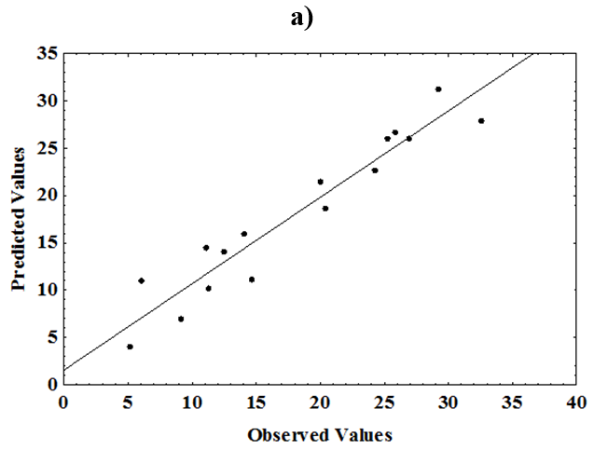
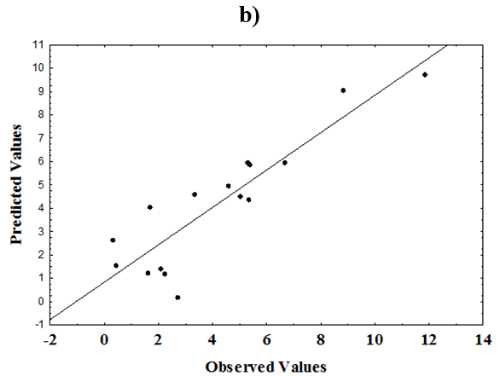

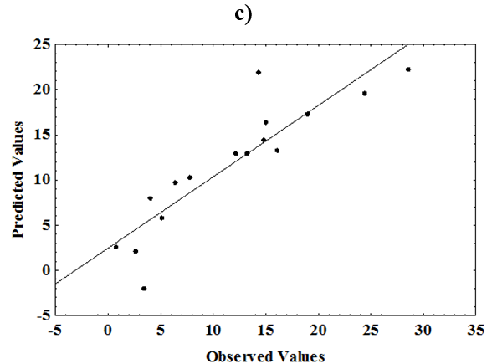
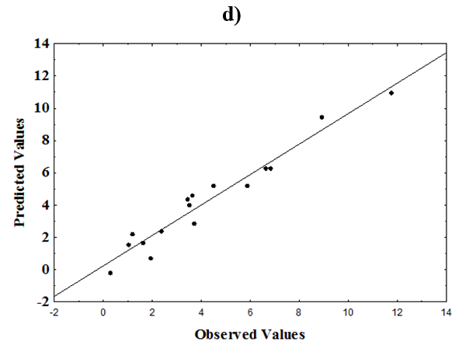
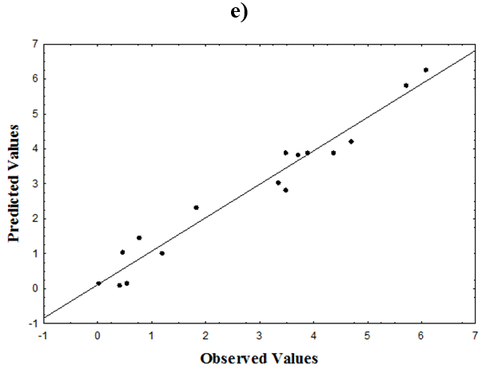
Figure 2. A comparative plot between the experimental and the predicted yield as a function of time (h), temperature (ºC), and pH for the enzymatic extracts from (a) P. aduncum, (b) P. tuberculatum, (c) P. crassinervium, (d) Peperomia blanda, and (e) P. obtusifolia.

After adjusting the model, the data were analyzed using the desirability function. After 20 h of reaction, the conversion of L-phenylalanine into trans-cinnamic acid did not increase significantly, and it proved to be the best reaction time. The analysis of its thermal resistance showed a maximum performance after 40 ºC, with an even larger increase above 49 ºC. The optimal pH for the reaction was 9.4 (Fig. 3).
The plot contour surface obtained for the enzymatic extracts illustrates the results (Fig. 4). Basic pH values (9.0 to 9.8) afforded the best results of L-phenylalanine conversion into trans-cinnamic acid. The thermostability of the enzyme was also evident: optimal reaction occurred at temperatures above 40 ºC. The conversion persisted even after 20 h despite the low rate. The previously described statistical procedure provided the Equations, which showed the r² value at a level of confidence of 95% for P. aduncum (A), P. tuberculatum (B), P. crassinervium (C), P. blanda (D), and P. obtusifolia (E) (Tab. 3).

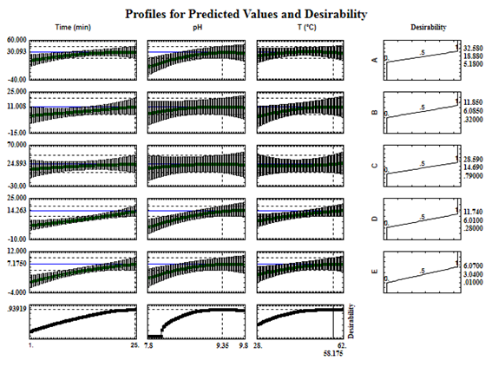
Figure 3. PAL activity from Piperaceae species taking independent and dependent variables into account: (A) P. aduncum, (B) P. tuberculatum, (C) P. crassinervium, (D) Peperomia blanda, and (E) P. obtusifolia.

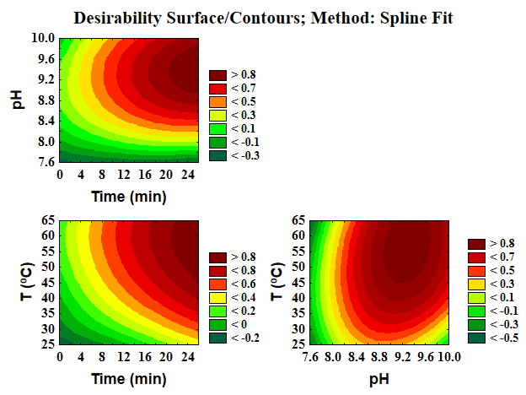
Figure 4. Contour surface graphs for the activity of the PAL enzyme using Response desirability surface/Contours.

Table 3. Coefficients of the Fitted Equations for the Construction of the Surface Response Plots.
Polynomial equation: a₀ + a₁X₁ + a₂X₂ + a₃X₃ + a₄X₁X₂ + a₅X₁X₃ + a₆X₂X₃ + a₇X₁² + a₈X₂² + a₉X₃²
 |  | Linear parameters |  |  |  |  |  |  | Quadratic Parameters
 | R² | a₀ | a₁ | a₂ | a₃ | a₄ | a₅ | a₆ | a₇ | a₈ | a₉
a | 0.91284 | -1038.26 | -2.02 | 229.43 | 0.92 | 0.50 | -0.01 | 0.17 | -0.05 | -13.35 | -0.02
b | 0.80069 | -202.386 | 0.514 | 46.986 | -0.539 | -0.065*t | 0.007 | 0.171 | 0.002 | -2.978 | -0.011
c | 0.78952 | -476.660 | 2.136 | 99.124 | 0.092 | -0.055 | -0.014 | -0.058 | -0.012 | -5.127 | 0.011
d | 0.94398 | -176.934 | -2.275 | 45.454 | -0.814 | 0.252 | 0.05 | 0.132 | 0.005 | -2.969 | -0.003
e | 0.95724 | -134.596 | -0.210 | 30.532 | -0.097 | 0.067 | 0.001 | 0.057 | -0.006 | -1.873 | -0.004

Besides checking the fit of the model and optimizing the operation conditions, the variables that most influenced the PAL activity of the different plant extracts were investigated (Fig. 5).

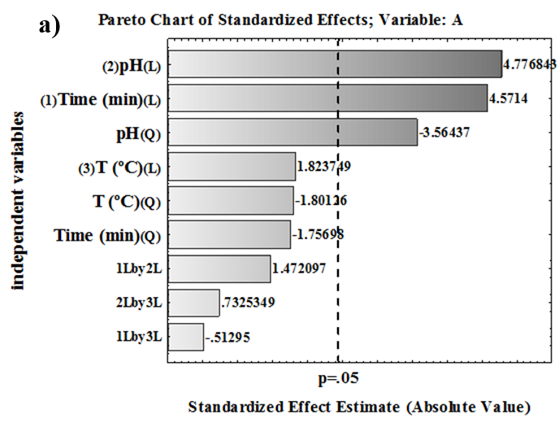

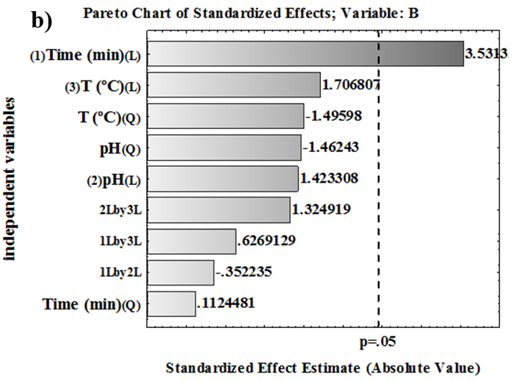
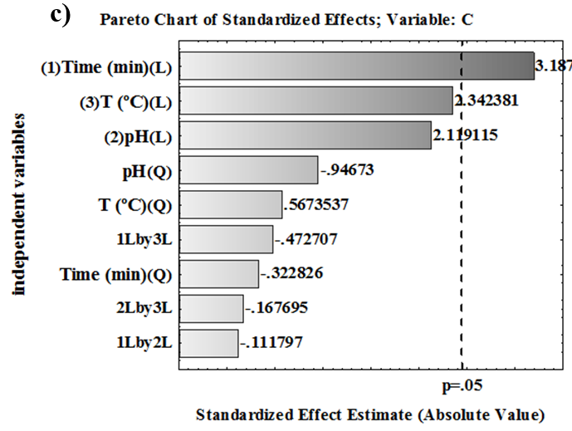
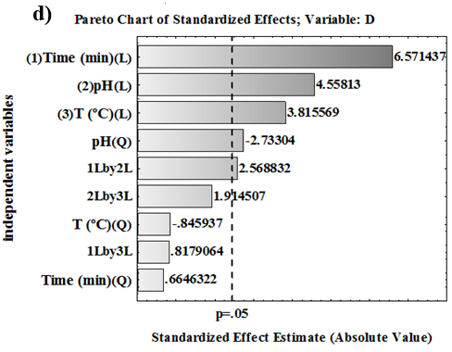
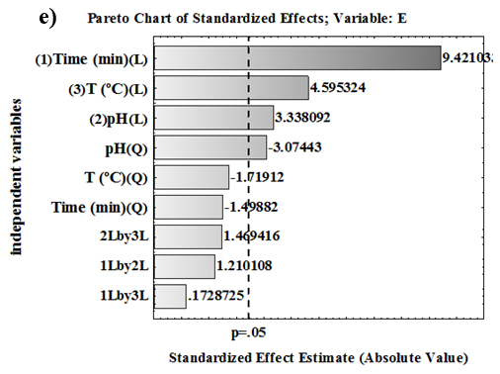
Figure 5. Analysis of the variables that most affect the activity of the PAL enzyme.

The variables that most influenced the process were pH and time. Regarding temperature, PAL showed the optimum activity at 58 °C in all plant species, showing thermal stability. These results corroborate their possible application in biotechnological processes.
Therefore, after determining the PAL optimum conditions, an ammonium sulfate precipitation was performed, and fractions of 0-25%, 25-55%, and 55-80 were obtained. The protein content of the enzymatic extracts obtained from leaves was determined and revealed that higher protein concentrations with 25-55% saturation were found in P. aduncum, P. tuberculatum, and P. blanda. However, P. crassinervium and P. obtusifolia displayed a higher protein content in the fraction with 55-80% saturation (Fig. 6a).

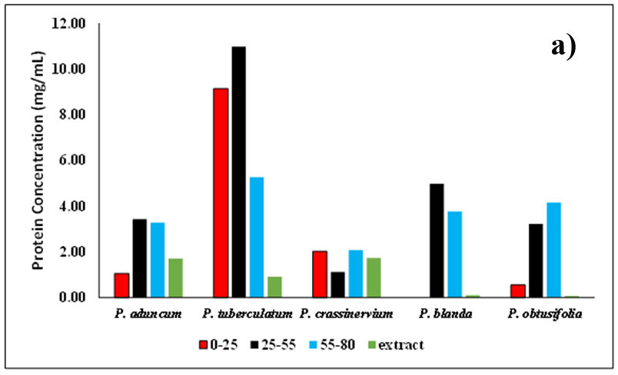
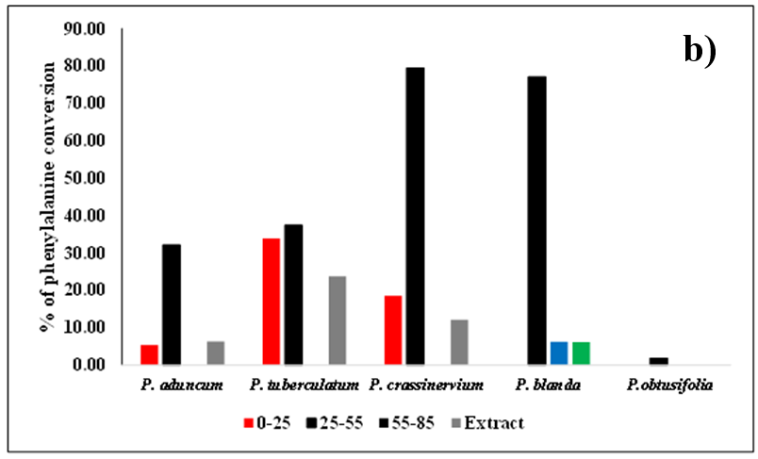
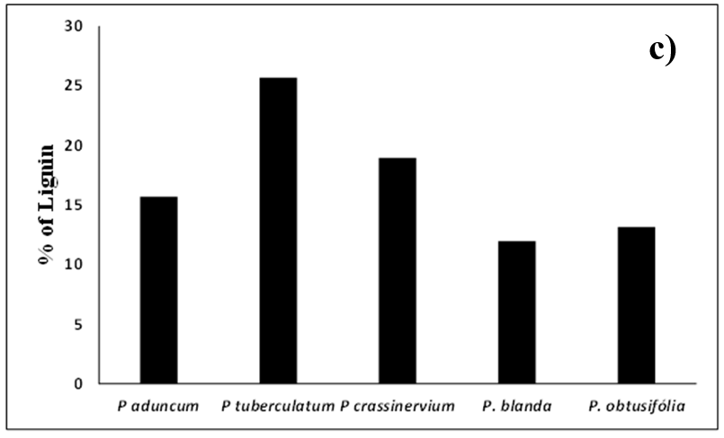
Figure 6. (a) Protein content in each of the fractions obtained after saline precipitation, (b) comparison of the degree of phenylalanine conversion to cinnamic acid, and (c) percentage of lignin.

By analyzing the obtained fraction with 25-55% of saturation with ammonium sulfate, it was verified that the specific activity in the P. aduncum species increased by approximately 133% (Tab. 4, Fig. 6b). Regarding P. tuberculatum, the specific activity decreased by 87.5% after the saline precipitation step. In Peperomia blanda, it was possible to verify a reduction in specific activity of 72.6%, also observed in P. tuberculatum. However, in P. crassinervium, the specific activity increased by more than 900% (Tab. 4), demonstrating to be an excellent source of PAL.

Table 4. Specific activity of PAL observed in the extracts and fractions after precipitation.
 | P. aduncum | P. tuberculatum | P. crassinervium | P. blanda | P. obtusifolia
 | (a) | (b) | (c) | (d) | (e)
Extract | 60 | 400 | 100 | 840 | 0
0-25% | 80 | 60 | 130 | 0 | 0
25-55% | 140 | 50 | 1057 | 230 | 9
55-85% | 0 | 0 | 0 | 20 | 0

Considering the last species studied, P. obtusifolia, it was possible to observe a significant increase in the specific activity of the PAL enzyme. However, as the protein concentration was too low (Fig. 6b), the use of the species during the attainment of the PAL enzyme in a large scale was not feasible (Tab. 4).
These fractions served as the source of the PAL enzyme in further experimental reactions. HPLC analyses evidenced that most of the desired enzyme, PAL, was concentrated in the fraction with 25-55% saturation, attested to the efficiency of the PAL concentration process. The degree of L-phenylalanine conversion to trans-cinnamic acid increased considerably in all cases, which facilitated the subsequent purification process (Fig. 6b).
Starting from the same mass of fresh leaves, the enzymatic extracts from P. crassinervium, P. tuberculatum, and P. blanda precipitated with 25-55% saturation of ammonium sulfate afforded the highest specific activities of PAL. However, the major secondary metabolites found in P. obtusifolia are chromanes. They differ from chromenes of P. aduncum, originated from the shikimate pathway and which require the p-hydroxybenzoic acid as a precursor. The chromanes are structurally related to the orsellinic acid, which is produced by the polyketide pathway. Therefore, these two distinct biosynthetic routes match with the lower PAL activity for P. obtusifolia.
In order to better characterize the Piperaceae species with a low level of phenylpropanoids pathway, experiments were conducted to examine the original lignin content in each species using the TAPPI test method (Fig. 6c). Data analyses of lignin contents demonstrated that the more rigid the leaves, the higher the lignin content (see data for P. aduncum, P. tuberculatum, and P. crassinervium). A small amount of lignin accumulated in the P. blanda species suggested that the biosynthetic pathway operated to produce secondary metabolites such as lignoids.
4. Conclusions

This work enabled the optimization of the reaction conditions to convert L-phenylalanine to trans-cinnamic acid catalyzed by the PAL enzyme extracted from five Piperaceae species (Piper aduncum, P. tuberculatum, P. crassinervium, Peperomia blanda and P. obtusifolia). Thenzymee exhibited thermostability, and the best reaction condition was pH 9.3 at a temperature of 58 °C for 25 h. It is important to mention that reaction times longer than 20 h do not give rise to significant improvement in the conversion, which did not justify longer reaction times. Pre-purification of the enzyme by ammonium sulfate precipitation showed that the ideal saturation was 25-55% — it increased the enzyme’s concentration and effectively improved phenylalanine’s conversion to cinnamic acid. Additionally, the thermal stability of the PAL may enable the use of the five studied Piperaceae species in specific green industrial processes.

Authors’ contribution

Conceptualization: Morandim-Giannetti, A. A.; Felippe, L. G.; Santos, V. A. F. F. M.; Kato, M. J.; Furlan, M.
Data curation: Morandim-Giannetti, A. A.; Felippe, L. G.; Santos, V. A. F. F. M.
Formal Analysis: Morandim-Giannetti, A. A.; Felippe, L. G.; Santos, V. A. F. F. M.; Kato, M. J.; Furlan, M.
Funding acquisition: Kato, M. J.; Furlan, M.
Investigation: Morandim-Giannetti, A. A.; Felippe, L. G.; Santos, V. A. F. F. M.; Kato, M. J.; Furlan, M.
Methodology: Morandim-Giannetti, A. A.; Felippe, L. G.; Santos, V. A. F. F. M.
Project administration: Morandim-Giannetti, A. A.; Felippe, L. G.; Furlan, M.
Resources: Morandim-Giannetti, A. A.; Felippe, L. G.; Santos, V. A. F. F. M.; Kato, M. J.; Furlan, M.
Software: Not applicable.
Supervision: Morandim-Giannetti, A. A.; Kato, M. J.; Furlan, M.
Validation: Morandim-Giannetti, A. A.
Visualization: Morandim-Giannetti, A. A.; Felippe, L. G.; Santos, V. A. F. F. M.; Kato, M. J.; Furlan, M.
Writing – original draft: Morandim-Giannetti, A. A.; Felippe, L. G.; Santos, V. A. F. F. M.; Kato, M. J.; Furlan, M.
Writing – review & editing: Morandim-Giannetti, A. A.; Furlan, M.

Data availability statement

All data generated or analyzed during this study are included in this published article.

Funding

São Paulo Research Foundation (FAPESP). Grant No: 2013/07600-3; 2014/50926-0.

Conselho Nacional de Desenvolvimento Científico e Tecnológico (CNPq). Grant. No: 2014/465637-0.

Acknowledgments

MF and MJK are grateful to the National Council for Scientific and Technological Development (CNPq) for their research fellowships.

References

Alves, N. S. F.; Setzer, W. N.; Silva, J. K. R. The chemistry and biological activities of Peperomia pellucida (Piperaceae): A critical review. J. Ethnopharmacol. 2019, 232, 90–102. https://doi.org/10.1016/j.jep.2018.12.021
Akbarian, A.; Rahimmalek, M.; Sabzalian, M. R.; Hodaei, M. Sequencing and phylogenetic analysis of phenylalanine ammonia lyase (pal) and chalcone synthase (chs) genes in some Iranian endemic species of Apiaceae. Gene Rep. 2021, 23, 101147. https://doi.org/10.1016/j.genrep.2021.101147
Arunachalam, K.; Damazo, A. S.; Macho, A.; Lima, J. C. S.; Pavan, E.; Figueiredo, F. F.; Oliveira, D. M.; Cechinel-Filho, V.; Wagner, T. M.; Tabajara, D.; Martins, D. T. O. Piper umbellatum L. (Piperaceae): Phytochemical profiles of the hydroethanolic leaf extract and intestinal anti-inflammatory mechanisms on 2, 4, 6 trinitrobenzene sulfonic acid induced ulcerative colitis in rats. J. Ethnopharmacol. 2020, 254, 112707. https://doi.org/10.1016/j.jep.2020.112707
Araújo-Vilges, K. M.; Oliveira, S. V.; Couto, S. C. P.; Fokoue, H. H.; Romero, G. A. S.; Kato, M. J.; Romeiro, L. A. S.; Leite, J. R. S. A.; Kuckelhaus, S. A. S. Effect of piplartine and cinnamides on Leishmania amazonensis, Plasmodium falciparum and on peritoneal cells of Swiss mice. Pharm. Biol. 2017, 55 (1), 1601–1607. https://doi.org/10.1080/13880209.2017.1313870
Banu, J. R.; Kavitha, S.; Kannah, R. Y.; Devi, T. P.; Gunasekaran, M.; Kim, S.-H.; Kumar, G. A review on biopolymer production via lignin valorization. Bioresour. Technol. 2019, 290, 121790. https://doi.org/10.1016/j.biortech.2019.121790
Batista, A. N. L.; Batista Junior, J. M.; Zocolo, G. J.; Zanoni, M. V. B.; Kato, M. J.; López, S. N.; Furlan, M. Protein and metabolic profiles of Peperomia obtusifolia (Piperaceae). Planta Med. 2012, 78 (11), PB3. https://doi.org/10.1055/s-0032-1320332
Batista, A. N. L.; Santos-Pinto, J. R. A. D.; Batista Junior, J. M.; Souza-Moreira, T. M.; Santoni, M. M.; Zanelli, C. F.; Kato, M. J.; López, S. N.; Furlan, M. The Combined Use of Proteomics and Transcriptomics Reveals a Complex Secondary Metabolite Network in Peperomia obtusifolia. J. Nat. Prod. 2017, 80 (5), 1275–1286. https://doi.org/10.1021/acs.jnatprod.6b00827
Batista Junior, J. M.; Lopes, A. A.; Ambrosio, D. L.; Regasini, L. O.; Kato, M. J.; Bolzani, V. S.; Cicarelli, R. M. B.; Furlan, M. Natural chromenes and chromene derivatives as potential anti-trypanosomal agents. Biol. Pharm. Bull. 2008, 31 (3), 538–540. https://doi.org/10.1248/bpb.31.538
Batista Junior, J. M.; López, S. N.; Mota, J. S.; Vanzolini, K. L.; Cass, Q. B.; Rinaldo, D.; Vilegas, W.; Bolzani, V. S.; Kato, M. J.; Furlan, M. Resolution and absolute configuration assignment of a natural racemic chromane from Peperomia obtusifolia (Piperaceae). Chirality 2009, 21 (9), 799–801. https://doi.org/10.1002/chir.20676
Batista Junior, J. M.; Batista, A. N. L.; Rinaldo, D.; Vilegas, W.; Cass, Q. B.; Bolzani, V. S.; Kato, M. J.; López, S. N.; Furlan, M.; Nafie, L. A. Absolute configuration reassignment of two chromanes from Peperomia obtusifolia (Piperaceae) using VCD and DFT calculations. Tetrahedron Asymmetry 2010, 21 (19), 2402–2407. https://doi.org/10.1016/j.tetasy.2010.09.004
Batista Junior, J. M.; Batista, A. N. L.; Kato, M. J.; Bolzani, V. S.; López, S. N.; Nafie, L. A.; Furlan, M. Further monoterpene chromane esters from Peperomia obtusifolia: VCD determination of the absolute configuration of a new diastereomeric mixture. Tetrahedron Lett. 2012, 53 (45), 6051–6054. https://doi.org/10.1016/j.tetlet.2012.08.113
Begović, L.; Abičić, I.; Lalić, A.; Lepeduš, H.; Cesar, V.; Leljak-Levanić, D. Lignin synthesis and accumulation in barley cultivars differing in their resistance to lodging. Plant Physiol. Biochem. 2018, 133, 142–148. https://doi.org/10.1016/j.plaphy.2018.10.036
Burton, B. K.; Longo, N.; Vockley, J.; Grange, D. K.; Harding, C. O.; Decker, C.; Li, M.; Lau, K.; Rosen, O.; Larimore, K.; Thomas, J. Pegvaliase for the treatment of phenylketonuria: Results of the phase 2 dose-finding studies with long-term follow-up. Mol. Genet. Metab. 2020, 130 (4), 239–246. https://doi.org/10.1016/j.ymgme.2020.06.006
Campelo, Y.; Ombredane, A.; Vasconcelos, A. G.; Albuquerque, L.; Moreira, D. C.; Plácido, A.; Rocha, J.; Fokoue, H. H.; Yamaguchi, L.; Mafud, A.; Mascarenhas, Y. P.; Delerue-Matos, C.; Borges, T.; Joanitti, G. A.; Arcanjo, D. D. R.; Kato, M. J.; Kuckelhaus, S. A. S.; Silva, M. P. N.; Moraes, J.; Leite, J. R. S. Structure–Activity relationship of piplartine and synthetic analogues against Schistosoma mansoni and cytotoxicity to mammalian cells. Int. J. Mol. Sci. 2018, 19 (6), 1802. https://doi.org/10.3390/ijms19061802
Choudhary, A. K.; Lee, Y. Y. The debate over neurotransmitter interaction in aspartame usage. J. Clin. Neurosci. 2018, 56, 7–15. https://doi.org/10.1016/j.jocn.2018.06.043
Corral, A. C. T.; Queiroz, M. N.; Andrade-Porto, S. M.; Morey, G. A. M.; Chaves, F. C. M.; Fernandes, V. L. A.; Ono, E. A.; Affonso, E. G. Control of Hysterothylacium sp. (Nematoda: Anisakidae) in juvenile pirarucu (Arapaima gigas) by the oral application of essential oil of Piper aduncum. Aquaculture. 2018, 494, 37–44. https://doi.org/10.1016/j.aquaculture.2018.04.062
Cortez, A. P.; Menezes, E. G. P.; Benfica, P. L.; Santos, A. P.; Cleres, L. M.; Ribeiro, H. O.; Lima, E. M.; Kato, M. J.; Valadares, M. C. Grandisin induces apoptosis in leukemic K562 cells. Braz. J. Pharm. Sci. 2017, 53 (1), e15210. https://doi.org/10.1590/s2175-97902017000115210
Danelutte, A. P.; Lago, J. H. G.; Young, M. C. M.; Kato, M. J. Antifungal flavanones and prenylated hydroquinones from Piper crassinervium Kunth. Phytochemistry. 2003, 64 (2), 555–559. https://doi.org/10.1016/S0031-9422(03)00299-1
Dong, C.-J.; Cao, N.; Zhang, Z.-g.; Shang, Q.-m. Phenylalanine ammonia-lyase gene families in cucurbit species: Structure, evolution, and expression. J. Integr. Agric. 2016, 15 (6), 1239–1255. https://doi.org/10.1016/S2095-3119(16)61329-1
Donlon, J.; Levy, H.; Scriver, C. R. Hyperphenylalaninemia: phenylalanine hydroxylase deficiency. In The metabolic and molecular bases of inherited disease. Scriver, C. R.; Beaudet, A. R.; Sly, W.; Valle, D. (Eds.). McGraw Hill, 2004; 1821–1838.
Durant-Archibold, A. A.; Santana, A. I.; Gupta, M. P. Ethnomedical uses and pharmacological activities of most prevalent species of genus Piper in Panama: A review. J. Ethnopharmacol. 2018, 217, 63–82. https://doi.org/10.1016/j.jep.2018.02.008
Englard, S.; Seifter, S. In Methods in Enzymology. Guide to Protein Purification. Academic Press, 1990; 285–300. https://doi.org/10.1016/0076-6879(90)82024-V
El Babili, F.; Rey-Rigaud, G.; Rozon, H.; Halova-Lajoie, B. State of knowledge: Histolocalisation in phytochemical study of medicinal plants. Fitoterapia. 2021, 150, 104862. https://doi.org/10.1016/j.fitote.2021.104862
Felippe, L. G.; Baldoqui, D. C.; Kato, M. J.; Bolzani, V. S.; Guimarães, E. F.; Cicarelli, R. M. B.; Furlan, M. Trypanocidal tetrahydrofuran lignans from Peperomia blanda. Phytochemistry. 2008, 69 (2), 445–450. https://doi.org/10.1016/j.phytochem.2007.08.012
Felippe, L. G.; Batista Junior, J. M.; Baldoqui, D. C.; Nascimento, I. R.; Kato, M. J.; He, Y.; Nafie, L. A.; Furlan, M. (2012). VCD to determine absolute configuration of natural product molecules: secolignans from Peperomia blanda. Org. Biomol. Chem. 2012 10 (21), 4208–4214. https://doi.org/10.1039/c2ob25109d
Ferreira, E. A.; Reigada, J. B.; Correia, M. V.; Young, M. C. M.; Guimarães, E. F.; Franchi Junior, G. C.; Nowill, A. E.; Lago, J. H. G.; Yamaguchi, L. F.; Kato, M. J. Antifungal and cytotoxic 2-acylcyclohexane-1, 3-diones from Peperomia alata and P. trineura. J. Nat. Prod. 2014, 77 (6), 1377–1382. https://doi.org/10.1021/np500130x
Finkelman M. A. J.; Yang, H. H. Production of phenylalanine ammonia lyase by fermentation. Genex Corporation, European Pat. 1985, 140, 714.
Freitas, G. C.; Batista Junior, J. M.; Franchi Junior, G. C.; Nowill, A. E.; Yamaguchi, L. F.; Vilcachagua, J. D.; Favaro, D. C.; Furlan, M.; Guimarães, E. F.; Jeffrey, C. S.; Kato, M. J. Cytotoxic non-aromatic B-ring flavanones from Piper carniconnectivum C. DC. Phytochemistry. 2014, 97, 81–87. https://doi.org/10.1016/j.phytochem.2013.10.012
Gao, Z.; Sun, W.; Wang, J.; Zhao, C.; Zuo, K. GhbHLH18 negatively regulates fiber strength and length by enhancing lignin biosynthesis in cotton fibers. Plant Sci. 2019, 286, 7–16. https://doi.org/10.1016/j.plantsci.2019.05.020
García-Huertas, P.; Olmo, F.; Sánchez-Moreno, M.; Dominguez, J.; Chahboun, R.; Triana-Chávez, O. Activity in vitro and in vivo against Trypanosoma cruzi of a furofuran lignan isolated from Piper jericoense. Exp. Parasitol. 2018, 189, 34–42. https://doi.org/10.1016/j.exppara.2018.04.009
Gutiérrez-Quequezana, L.; Vuorinen, A. L.; Kallio, H.; Yang, B. Impact of cultivar, growth temperature and developmental stage on phenolic compounds and ascorbic acid in purple and yellow potato tubers. Food Chem. 2020, 326, 126966. https://doi.org/10.1016/j.foodchem.2020.126966
Hamedan, H. J.; Sohani, M. M.; Aalami, A.; Nazarideljou, M. J. Genetic engineering of lignin biosynthesis pathway improved stem bending disorder in cut gerbera (Gerbera jamesonii) flowers. Sci. Hortic. 2019, 245, 274–279. https://doi.org/10.1016/j.scienta.2018.10.013
Hamilton, B. K.; Hsiao, H.-Y.; Swann, W.; Anderson, D. M.; Delente, J. J. Manufacture of L-amino, acids with bioreactors. Trends Biotechnol. 1985, 3 (3), 64–68. https://doi.org/10.1016/0167-7799(85)90079-4
Hartnett, C.; Salvarinova-Zivkovic, R.; Yap-Todos, E.; Cheng, B.; Giezen, A.; Horvath, G.; Lillquist, Y.; Vallance, H.; Stockler-Ipsiroglu, S. Long-term outcomes of blood phenylalanine concentrations in children with classical phenylketonuria. Mol. Gen. Metab. 2013, 108 (4), 255–258. https://doi.org/10.1016/j.ymgme.2013.01.007
Huang, S.-J.; Lin, S.-Y.; Wang, T.-T.; Hsu, F.-C. Combining acetic acid and ethanol as an anti-browning treatment for lettuce butt discoloration through repression of the activity and expression of phenylalanine ammonia lyase. Postharvest Biol. Technol. 2020, 164, 111151. https://doi.org/10.1016/j.postharvbio.2020.111151
Hussain, S.; Iqbal, N.; Pang, T.; Khan, M. N.; Liu, W.-g.; Yang, W.-y. Weak stem under shade reveals the lignin reduction behavior. J. Integr. Agric. 2019, 18 (3), 496–505. https://doi.org/10.1016/S2095-3119(18)62111-2
Jeffrey, C. S.; Leonard, M. D.; Glassmire, A. E.; Dodson, C. D.; Richards, L. A.; Kato, M. J.; Dyer, L. A. Antiherbivore Prenylated Benzoic Acid Derivatives from Piper kelleyi. J. Nat. Prod. 2014, 77 (1), 148–153. https://doi.org/10.1021/np400886s
Kamdee, C.; Imsabai, W.; Kirk, R.; Allan, A. C.; Ferguson, I. B.; Ketsa, S. Regulation of lignin biosynthesis in fruit pericarp hardening of mangosteen (Garcinia mangostana L.) after impact. Postharvest Biol. Technol. 2014, 97, 68–76. https://doi.org/10.1016/j.postharvbio.2014.06.004
Kato, M. J.; Furlan, M. Chemistry and evolution of the Piperaceae. Pure Appl. Chem. 2007, 79 (4), 529–538. https://doi.org/10.1351/pac200779040529
Kawatra, A.; Dhankhar, R.; Mohanty, A.; Gulati, P. Biomedical applications of microbial phenylalanine ammonia lyase: current status and future prospects. Biochimie. 2020, 177, 142–152. https://doi.org/10.1016/j.biochi.2020.08.009
Kitamura, R. O. S.; Romoff, P.; Young, M. C. M.; Kato, M. J.; Lago, J. H. G. Chromenes from Peperomia serpens (Sw.) Loudon (Piperaceae). Phytochemistry. 2006, 67 (21), 2398–2402. https://doi.org/10.1016/j.phytochem.2006.08.007
Klejdus, B.; Kováčik, J.; Babula, P. PAL inhibitor evokes different responses in two Hypericum species. Plant Physiol. Biochem. 2013, 63, 82–88. https://doi.org/10.1016/j.plaphy.2012.11.019
Lago, J. H. G.; Ramos, C. S.; Casanova, D. C. C.; Morandim, A. A.; Bergamo, D. C. B.; Cavalheiro, A. J.; Bolzani, V. S.; Furlan, M.; Guilharães, E. F.; Young, M. C. M.; Kato, M. J. Benzoic acid derivatives from Piper species and their fungitoxic activity against Cladosporium cladosporioides and C. sphaerospermum, J. Nat. Prod. 2004, 67 (11), 1783–1788. https://doi.org/10.1021/np030530j
Lago, J. H. G.; Young, M. C. M.; Reigada, J. B.; Soares, M. G.; Roesler, B. P.; Kato, M. J. Antifungal derivatives from Piper mollicomum and P. lhotzkyanum (Piperaceae). Quim. Nova 2007, 30 (5), 1222–1224. https://doi.org/10.1590/S0100-40422007000500032
Levy, H. L.; Sarkissian, C. N.; Scriver, C. R. Phenylalanine ammonia lyase (PAL): From discovery to enzyme substitution therapy for phenylketonuria. Mol. Genet. Metab. 2018, 124 (4), 223–229. https://doi.org/10.1016/j.ymgme.2018.06.002
Liu, W.-g.; Hussain, S.; Liu, T.; Zou, J.-l.; Ren, M.-l.; Zhou, T.; Liu, J.; Yang, F.; Yang, W.-y. Shade stress decreases stem strength of soybean through restraining lignin biosynthesis. J. Integr. Agric. 2019, 18 (1), 43–53. https://doi.org/10.1016/S2095-3119(18)61905-7
Lopes, A. A.; Baldoqui, D. C.; López, S. N.; Kato, M. J.; Bolzani, V. S.; Furlan, M. Biosynthetic origins of the isoprene units of gaudichaudianic acid in Piper gaudichaudianum (Piperaceae). Phytochemistry. 2007, 68 (15), 2053–2058. https://doi.org/10.1016/j.phytochem.2007.04.025
López, S. N.; Lopes, A. A.; Batista Junior, J. M.; Flausino Junior, O.; Bolzani, V. S; Kato, M. J.; Furlan, M. Geranylation of benzoic acid derivatives by enzymatic extracts from Piper crassinervium (Piperaceae). Bioresour. Technol. 2010, 101 (12), 4251–4260. https://doi.org/10.1016/j.biortech.2010.01.041
Macêdo, C. G.; Fonseca, M. Y. N.; Caldeira, A. D.; Castro, S. P.; Pacienza-Lima, W.; Borsodi, M. P. G.; Sartoratto, A.; Silva, M. N.; Salgado, C. G.; Rossi-Bergmann, B.; Castro, K. C. F. Leishmanicidal activity of Piper marginatum Jacq. from Santarém-PA against Leishmania amazonensis. Exp. Parasitol. 2020, 210, 107847. https://doi.org/10.1016/j.exppara.2020.107847
Machado, M.; Felizardo, C.; Fernandes-Silva, A.; Nunes, F. M.; Barros, A. Polyphenolic compounds, antioxidante activity and L-phenylalanine ammonia-lyase activity during ripening of olive cv. “Cobrançosa” under different irrigation regimes. Food Res. Int. 2013, 51 (1), 412–421. https://doi.org/10.1016/j.foodres.2012.12.056
Maleck, M.; Ferreira, B.; Mallet, J.; Guimaróes, A.; Kato, M. J. Cytotoxicity of Piperamides Towards Aedes aegypti (Diptera: Culicidae). J. Med. Entomol. 2014, 51 (2), 458–463. https://doi.org/10.1603/ME13069
Marques, J. V.; Oliveira, A. D.; Raggi, L.; Young, M. C. M.; Kato, M. J. Antifungal activity of natural and synthetic amides from Piper species. J. Braz. Chem. Soc. 2010, 21 (10), 1807–1813. https://doi.org/10.1590/S0103-50532010001000003
Martins, R. C. C.; Lago, J. H. G.; Albuquerque, S.; Kato, M. J. Trypanocidal tetrahydrofuran lignans from Piper solmsianum. Phytochemistry. 2003, 64 (2), 667–670. https://doi.org/10.1016/S0031-9422(03)00356-X
Mgbeahuruike, E. E.; Yrjönen, T.; Vuorela, H.; Holm, Y. Bioactive compounds from medicinal plants: Focus on Piper species. S. Afr. J. Bot. 2017, 112, 54–69. https://doi.org/10.1016/j.sajb.2017.05.007
Miranda, J. E.; Navickiene, H. M. D.; Nogueira-Couto, R. H.; Bortoli, S. A.; Kato, M. J.; Bolzani, V. S.; Furlan, M. Susceptibility of Apis mellifera (Hymenoptera: Apidae) to pellitorine, an amide isolated from Piper tuberculatum (Piperaceae). Apidologie. 2003, 34 (4), 409–415. https://doi.org/10.1051/apido:2003036
Moraes, J.; Keiser, J.; Ingram, K.; Nascimento, C.; Yamaguchi, L. F.; Bittencourt, C. R.; Bemquerer, M. P.; Leite, J. R.; Kato, M, J.; Nakano, E. In vitro synergistic interaction between amide piplartine and antimicrobial peptide dermaseptin against Schistosoma mansoni schistosomula and adult worms. Curr. Med. Chem. 2013, 20 (2), 301–309. https://doi.org/10.2174/092986713804806694
Moraes, M. M.; Kato, M. J. Biosynthesis of Pellucidin A in Peperomia pellucida (L.) HBK. Front. Plant Sci. 2021, 12, 641717. https://doi.org/10.3389/fpls.2021.641717
Morandim, A. A; Bergamo, D. C. B.; Kato, M. J.; Cavalheiro, A. J.; Bolzani, V. S., Furlan, M. Circadian rhythm of anti‐fungal prenylated chromene in leaves of Piper aduncum. Phytochemical Anal. 2005, 16 (4), 282–286. https://doi.org/10.1002/pca.843
Mota, J. S.; Leite, A. C.; Batista Junior, J. M.; López, S. N.; Ambrósio, D. L.; Passerini, G. D.; Kato, M. J.; Bolzani, V. S.; Cicarelli, R. M. B.; Furlan, M. In vitro Trypanocidal Activity of Phenolic Derivatives from Peperomia obtusifolia. Planta Med. 2009, 75 (6), 620–623. https://doi.org/10.1055/s-0029-1185364
Mota, J. S.; Leite, A. C.; Kato, M. J.; Young, M. C. M.; Bolzani, V. D. S.; Furlan, M. Isoswertisin flavones and other constituents from Peperomia obtusifolia. Nat. Prod. Res. 2011, 25 (1), 1–7. https://doi.org/10.1080/14786410903244954
Navickiene, H. M. D.; Alécio, A. C.; Kato, M. J.; Bolzani, V. D. S.; Young, M. C. M.; Cavalheiro, A. J.; Furlan, M. Antifungal amides from Piper hispidum and Piper tuberculatum. Phytochemistry. 2000, 55 (6), 621–626. https://doi.org/10.1016/S0031-9422(00)00226-0
Navickiene, H. M. D; Bolzani, V. S.; Kato, M. J; Pereira, A. M. S.; Bertoni, B. W.; Furlan, M. Quantitative determination of anti-fungal and insecticide amides in adult plants, plantlets and callus from Piper tuberculatum by reverse-phase high-performance liquid chromatography. Phytochem. Anal. 2003, 14 (5), 281–284. https://doi.org/10.1002/pca.716
Neves, A. R.; Trefzger, O. S.; Barbosa, N. V.; Honorato, A. M.; Carvalho, D. B.; Moslaves, I. S.; Kadri, M. C. T.; Yoshida, N. C.; Kato, M. J.; Arruda, C. C. P.; Baroni, A. C. Effect of isoxazole derivatives of tetrahydrofuran neolignans on intracellular amastigotes of Leishmania (Leishmania) amazonensis: A structure–activity relationship comparative study with triazole‐neolignan‐based compounds. Chem. Biol. Drug Des. 2019, 94 (6), 2004–2012. https://doi.org/10.1111/cbdd.13609
Oliveira, A.; Mesquita, J. T.; Tempone, A. G.; Lago, J. H. G.; Guimarães, E. F.; Kato, M. J. Leishmanicidal activity of an alkenylphenol from Piper malacophyllum is related to plasma membrane disruption. Exp. Parasitol. 2012, 132 (3), 383–387. https://doi.org/10.1016/j.exppara.2012.08.019
Pereira Filho, A. A.; Pessoa, G. C. D.; Yamaguchi, L. F.; Stanton, M. A.; Serravite, A. M.; Pereira, R. H. M.; Neves, W. S.; Kato, M. J. Larvicidal activity of essential oils from Piper species against strains of Aedes aegypti (Diptera: Culicidae) resistant to pyrethroids. Front. Plant Sci. 2021, 12. https://doi.org/10.3389/fpls.2021.685864
Pinheiro, B. G.; Silva, A. S. B.; Souza, G. E. P.; Figueiredo, J. G.; Cunha, F. Q.; Lahlou, S.; Silva, J. K. R.; Maia, J. G. S.; Sousa, P. J. C. Chemical composition, antinociceptive and anti-inflammatory effects in rodents of the essential oil of Peperomia serpens (Sw.) Loud. J. Ethnopharmacol. 2011, 138 (2), 479–486. https://doi.org/10.1016/j.jep.2011.09.037
Prabpree, A.; Sangsil, P.; Nualsri, C.; Nakkanong, K. Expression profile of phenylalanine ammonia-lyase (PAL) and phenolic content during early stages of graft development in bud grafted Hevea brasiliensis. Biocatal. Agric. Biotechnol. 2018, 14, 88–95. https://doi.org/10.1016/j.bcab.2018.02.010
Ramos, C. S.; Kato, M. J. Metabolism of neolignans from P. regnellii (Piperaceae) in the beetle Naupactus bipes (Coleoptera: Curculionidae). Chemoecology. 2013, 23 (3), 143–148. https://doi.org/10.1007/s00049-013-0129-y
Ramos, C. S.; Silva, M. W.; Moraes, M. M.; Almeida, A. V.; Vanin, S. A.; Kato, M. J. Metabolization of Insecticidal Amides from Leaves of Piper tuberculatum by Heraclydes hectorides and Naupactus bipes. J. Braz. Chem. Soc. 2020, 31 (4), 724–730. https://doi.org/10.21577/0103-5053.20190236
Regasini, L. O.; Cotinguiba, F.; Siqueira, J. R.; Bolzani, V. S.; Silva, D. H.; Furlan, M., Kato, M. J. Radical scavenging capacity of Piper arboreum and Piper tuberculatum (Piperaceae). Lat. Am. J. Pharm. 2008, 27 (6), 900–903.
Regasini, L. O.; Cotinguiba, F.; Passerini, G. D.; Bolzani, V. D. S.; Cicarelli, R. M. B.; Kato, M. J.; Furlan, M. Trypanocidal activity of Piper arboreum and Piper tuberculatum (Piperaceae). Rev. Bras. Farmacogn. 2009, 19 (1b), 199–203. https://doi.org/10.1590/S0102-695X2009000200003
Reigada, J. B.; Tcacenco, C. M.; Andrade, L. H.; Kato, M. J.; Porto, A. L.; Lago, J. H. G. Chemical constituents from Piper marginatum Jacq. (Piperaceae)—antifungal activities and kinetic resolution of (RS)-marginatumol by Candida antarctica lipase (Novozym 435). Tetrahedron Asymmetry 2007, 18 (9), 1054–1058. https://doi.org/10.1016/j.tetasy.2007.05.006
Rocha, J. C.; Bausell, H.; Bélanger-Quintana, A.; Bernstein, L.; Gökmen-Özel, H.; Jung, A.; MacDonald, A.; Rohr, F.; van Dam, E.; Heddrich-Ellerbrok, M. Development of a practical dietitian road map for the nutritional management of phenylketonuria (PKU) patients on pegvaliase. Mol. Genet. Metab. 2021, 28, 100771. https://doi.org/10.1016/j.ymgmr.2021.100771
Salazar, K. J. M.; Paredes, G. E. D.; Lluncor, L. R.; Young, M. C. M.; Kato, M. J. Chromenes of polyketide origin from Peperomia villipetiola. Phytochemistry. 2005, 66 (5), 573–579. https://doi.org/10.1016/j.phytochem.2005.01.003
Sant’Ana, M.; Souza, H. R.; Possebon, L.; Cornélio, M. L.; Riffo-Vasquez, Y.; Girol, A. P.; Oliani, S. M. Effect of piperlongumine during exposure to cigarette smoke reduces inflammation and lung injury. Pulm. Pharmacol. Ther. 2020, 61, 101896. https://doi.org/10.1016/j.pupt.2020.101896
Santos, R. A.; Ramos, C. S.; Young, M. C. M.; Pinheiro, T. G.; Amorim, A. M.; Kato, M. J.; Batista, R. Antifungal constituents from the roots of Piper dilatatum Rich. J. Chem. 2013, 2013, 160165. https://doi.org/10.1155/2013/160165
Sarkissian, C. N.; Kang, T. S.; Gámez, A.; Scriver, C. R.; Stevens, R. C. Evaluation of orally administered PEGylated phenylalanine ammonia lyase in mice for the treatment of Phenylketonuria, Mol. Gen. Metab. 2011, 104 (3), 249–254. https://doi.org/10.1016/j.ymgme.2011.06.016
Silva, R. V.; Navickiene, H. M. D.; Kato, M. J.; Bolzani, V. D. S.; Méda, C. I.; Young, M. C. M.; Furlan, M. Antifungal amides from Piper arboreum and Piper tuberculatum. Phytochemistry. 2002, 59 (5), 521–527. https://doi.org/10.1016/S0031-9422(01)00431-9
Silva, J. K. R.; Andrade, E. H. A.; Kato, M. J.; Carreira, L. M. M.; Guimaraes, E. F.; Maia, J. G. S. Antioxidant capacity and larvicidal and antifungal activities of essential oils and extracts from Piper krukoffii. Nat. Prod. Comm. 2011, 6 (9), 1361–1366. https://doi.org/10.1177/1934578X1100600936
Silva, H. A.; Yamaguchi, L. F.; Young, M. C. M.; Ramos, C. S.; Amorim, A. M. A.; Kato, M. J.; Batista, R. Antifungal piperamides from Piper mollicomum Kunth (Piperaceae). Eclet. Quim. J. 2018, 43 (1), 33–38. https://doi.org/10.26850/1678-4618eqj.v43.1.2018.p33-38
Silva, N. V.; Mazzafera, P.; Cesarino, I. Should I stay or should I go: are chlorogenic acids mobilized towards lignin biosynthesis? Phytochemistry. 2019a, 166, 112063. https://doi.org/10.1016/j.phytochem.2019.112063
Silva, A. C. A.; Diodato, J. S.; Castro, J. W.; Matias, E. F. F.; Silva, L. E.; Amaral, W.; Maia, B. H. L. N. S.; Ferriani, A. P.; Souza, A. K.; Quintans-Júnior, L. J.; Coutinho, H. D. M. Effect of the essential oils from Piper sp. and blue led lights in the enhancement of the antibiotic activity of drugs against mdr bacterial strains. J. Photochem. Photobiol. B. 2019b, 199, 111604. https://doi.org/10.1016/j.jphotobiol.2019.111604
Silva, M. A.; Fokoue, H. H.; Fialho, S. N.; Santos, A. P. A.; Rossi, N. R. D. L. P.; Gouveia, A. J.; Ferreira, A. S.; Passarini, G. M.; Garay, A. F. G.; Alfonso, J. J.; Soares, A. M.; Zanchi, F. B.; Kato, M. J.; Teles, C. B. G.; Kuehn, C. C. Antileishmanial activity evaluation of a natural amide and its synthetic analogs against Leishmania (V.) braziliensis: an integrated approach in vitro and in silico. Parasitol. Res. 2021, 120 (4), 2199–2218. https://doi.org/10.1007/s00436-021-07169-w
Souza, A. A.; Vessecchi, R.; Castro‐Gamboa, I.; Furlan, M. Combined use of tandem mass spectrometry and computational chemistry to study 2H‐chromenes from Piper aduncum. J. Mass Spectrom. 2019, 54 (7), 634–642. https://doi.org/10.1002/jms.4378
TAPPI - Technical Association of the Pulp and Paper Industry. Official Test Methods, Provisional Test Methods, and Useful Test Methods - Fibrous Materials and Pulp. Testing. Atlanta, 1979.
Toscano, S.; Ferrante, A.; Leonardi, C.; Romano, D. PAL activities in asparagus spears during storage after ammonium sulfate treatments. Postharvest Biol. Technol. 2018, 140, 34–41. https://doi.org/10.1016/j.postharvbio.2018.02.010
Tronchet, M.; Balagué, C.; Kroj, T.; Jouanin, L.; Roby, D. Cinnamyl alcohol dehydrogenases C and D, key enzymes in lignin biosynthesis, play an essential role in disease resistance in Arabidopsis. Mol. Plant Pathol. 2010, 11 (1), 83–92. https://doi.org/10.1111/j.1364-3703.2009.00578.x
Vanholme, R.; Meester, B.; Ralph, J.; Boerjan, W. Lignin biosynthesis and its integration into metabolism. Curr. Opin. Biotechnol. 2019, 56, 230–239. https://doi.org/10.1016/j.copbio.2019.02.018
Veronico, P.; Paciolla, C.; Pomar, F.; De Leonardis, S.; García-Ulloa, A.; Melillo, M. T. Changes in lignin biosynthesis and monomer composition in response to benzothiadiazole and root-knot nematode Meloidogyne incognita infection in tomato. J. Plant Physiol. 2018, 230, 40–50. https://doi.org/10.1016/j.jplph.2018.07.013
Vogel, K. R.; Arning, E.; Wasek, B. L.; Bottiglieri, T.; Gibson, K. M. Characterization of 2-(methylamino) alkanoic acid capacity to restrict blood-brain phenylalanine transport in Pahe^{nu2} mice: Preliminary findings. Mol. Gen. Metab. 2013, 110 (Suppl), S71–S78. https://doi.org/10.1016/j.ymgme.2013.08.004
Watanabe, S. K.; Hemandez-Velazco, G.; Iturbe-Chiñas, F.; Lopez-Mungia, A. Phenylalanine ammonia lyase from Sporidiobolus pararoseus and Rhodosporidium toruloides: application for phenylalanine and tyrosine deamination. World J. Microbiol. Biotechnol. 1992, 8 (4), 406–410. https://doi.org/10.1007/BF01198755
Weiss, R.; Guebitz, G. M.; Pellis, A.; Nyanhongo, G. S. Harnessing the Power of Enzymes for Tailoring and Valorizing Lignin. Trends Biotechnol. 2020, 38 (11), 1215–1231. https://doi.org/10.1016/j.tibtech.2020.03.010
Yamaguchi, L. F.; Lago, J. H. G.; Tanizaki, T. M.; Di Mascio, P.; Kato, M. J. Antioxidant activity of prenylated hydroquinone and benzoic acid derivatives from Piper crassinervium Kunth. Phytochemistry. 2006, 67 (16), 1838–1843. https://doi.org/10.1016/j.phytochem.2006.03.001
Yoshida, N. C.; Benedetti, A. M.; Santos, R. A.; Ramos, C. S.; Batista, R.; Yamaguchi, L. F.; Kato, M. J. Alkenylphenols from Piper dilatatum and P. diospyrifolium. Phytochemistry Lett. 2018, 25, 136–140. https://doi.org/10.1016/j.phytol.2018.04.006
You, X.; Fang, H.; Wang, R.; Wang, G.-L.; Ning, Y. Phenylalanine ammonia lyases mediate broad-spectrum resistance to pathogens and insect pests in plants. Sci. Bull. 2020, 65 (17), 1425–1427. https://doi.org/10.1016/j.scib.2020.05.014

