Persons, Property, and Community

Margaret Davies*

- Introduction
We use the terms ‘persons’ and ‘property’ in our everyday lives quite happily, without needing to give them a technical meaning. On the whole, we seem to know what they mean and how to use them.
Lawyers also use these terms routinely and in the quite ordinary course of events. Like many legal concepts, however, they suffer from much ambiguity: both the objects to which they refer and their underlying concepts are uncertain and the subject of frequent political controversy. Indeed, in both cases, it is doubtful whether an ‘underlying legal concept’ even exists, such is the difficulty of defining them clearly. The problem is amplified because the everyday usages of the terms ‘persons’ and ‘property’, are sometimes at odds with legal definitions, and in this sense, these terms are no different to many others. Having said that, law is embedded in social practice and the distinction between the legal and the non-legal is a convenient fiction maintained by law. In consequence, there is often both cross-fertilisation of ‘legal’ and ‘everyday’ or social meanings, as well as a certain productive tension between them.
I wish to do three things in this paper. First, I wish briefly to introduce some of the difficulties with the concepts of persons and property, what they refer to, and how they are used. Second, I will explain what I see as the relationship between these two ideas – how they are supposed to be diametrically opposed, and how they are in fact inextricably linked. Up to this point I will be selecting from and summarising a mountainous literature on the topic. The third and more substantial part of my paper will take the matter in a new direction. Here I will try to capture new ways of thinking about property which in some ways loosen the property-person nexus, without breaking it altogether. In essence, these new approaches introduce values associated with the community, the environment, and our material futures into our thinking.
Before commencing, I should point out that there is very little that is unquestionable or fixed in this analysis. Marilyn Strathern says that ‘Anthropologists use relationships to uncover relationships’ (2005: vii). It is also the case that if anything can be said with certainty about my topic it is that the property-person thematic is entirely about layers and layers of highly dynamic relationships. These relationships implicate people, communities, ideas, politics, and the physical world. They are intrinsically impossible to pin down or conceptualise in their entirety, so my aim is simply to draw out a few significant threads.
Persons
To begin then, what is a person? The everyday use of the term simply points to biological ‘human beings’ or what lawyers call ‘natural persons’. In an everyday setting we do not ordinarily have trouble using the word ‘person’ even if we are acutely aware that the biological human being is only constituted as a social person by a complex web of norms, values, and practices.
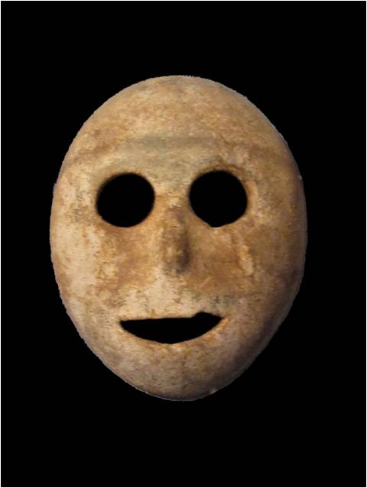
Lawyers have more trouble with the notion of person, as it is usually seen as an abstract term or container which may be filled with ontologically quite variable contents. In classical theatre ‘persona’ was the mask worn by an actor to denote the character they assumed in the play: artifice or fiction is the key here and characterises the predominant theory of the legal person (Naffine 2003: 352) which sees it as simply an empty legal form – each legal person, human or not, is as artificial to law as the next because the person is simply any entity that bears a right or duty of any sort. The corporation – entirely a construction of law – is a legal person, as are certain office bearers such as Ministers of the Crown who, as ‘corporations sole’, may have dual or even multiple legal status as artificial legal persons and human beings. On the so-called ‘natural’ side, human beings precede and exceed their ‘legal’ status because, unlike corporations, they are not entirely defined by law. Nonetheless, many human beings have limited status as legal persons on account of their (young) age, their mental capacity, their citizenship, their criminal record, and, in the past, their gender, heritage, and race. Enslaved human beings had few or no rights, and were therefore not persons (but rather property). Richard Tur calls the person a ‘cluster concept’, adding that ‘it is conceivable that two entities, both of which are legal persons, might have no rights and duties in common at all’ (Tur, 1987: 122).
A ‘persona’ is a mask
(Image by Gryffindor: Creative Commons Attribution-Share Alike 3.0 License, Wikimedia Commons)
It is partly for this reason that law has been able to find so many ways to discriminate against women, sexual and religious minorities, foreigners, and the unpropertied. Legal personality is simply shaped to whatever form is desired – whether this means an inability to vote, to own property, to set up business, to practice a profession, to marry, enter into a contract, or whatever. Legal rights vary from one person to the next, and there would be absolutely no technical difficulty in attributing some limited legal personality to animals, trees, or ecosystems as long as they had some guardian to act on their behalf, as many humans do. There is no essential ‘person’ underlying the legal concept: it is simply an ‘empty slot’ (Tur 1987: 121).
However, as Ngaire Naffine makes very clear in her writings on the subject, the law is not a mathematical system, and this formal understanding of the legal person is both supplemented and undermined by more human-centred notions of the person. In effect, when it comes to human beings, law cannot maintain a purely formal approach – decisions have to be made, for instance, about the beginning and end of lives, about the status of the foetus, the loss of rights upon death, and about mental capacity – essentially about what the human is who has rights.
There is often a tendency to naturalise the person by asking what are the real or inherent characteristics of a human being – we are often said to be essentially rational, for instance, or essentially sentient. Yet as soon as we move beyond purely biological descriptions to socially-loaded values, this so-called natural person is as much of an artifice as the legal person: the distinctions between human and animal, human and object, and between humans that exist in the present and those who have existed or will exist, are all constructed within political and cultural frames. Lines are drawn and characteristics are attributed.
In its efforts to reflect this so-called natural human with its inalienable rights, the legal person becomes a battleground for vastly different political and religious views about the human body, the human being, and the nature of human rights. Some of the most bitter legal contests occur in relation to the beginnings and end of human life, in questions concerning the status of the foetus or those in a persistent vegetative state (Hamilton, 2009: 3-10). But there are a multitude of questions which might be asked about the legal person which are inflected with our cultural narratives about natural persons – why, for instance, must legal persons be given a sex? Why do we not give animals rights (Francione 2008)? What rights are most significant to persons? These controversies go to the heart of our self-perception as human beings – they are essentially about who we are.
Property
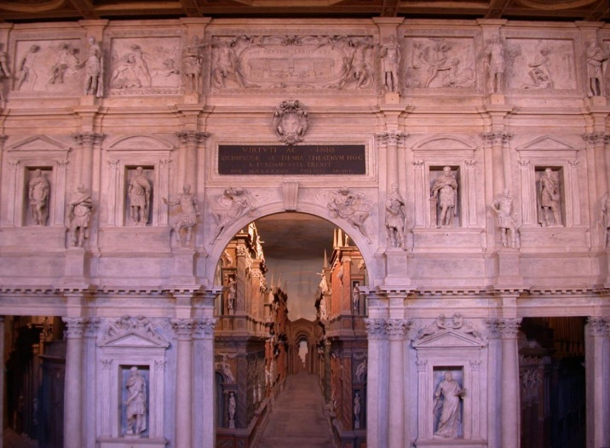
When we think about property the situation is no clearer. In fact, it is probably even more complex. Once again, property is a term in everyday use which appears relatively straightforward. Once again, lawyers often use the term in a quite different way – not to mean things which are owned, but rather relationships between persons which distribute rights regarding things. And once again, there can be a startling lack of legal clarity over both the things which can be the subject of property rights, and what property means in essence. Property theorist Kevin Gray has referred to ‘the remarkably incoherent and unanalytical way in which the term “property” is generally bandied about by common lawyers’. (2007: 170). Around 10 years ago, the High Court of Australia, quoting Gray, said ‘the ultimate fact about property is that it does not really exist: it is mere illusion’ (cf Gray 1991: 252).
Is property an illusion?
(Image by Gvf: Creative Commons Attribution-Share Alike 3.0 License, Wikimedia Commons)

Like the person, property can be regarded as an ‘empty slot’ into which all sorts of rights can be fitted. The law simply identifies and shapes property – always having some conceptual or physical thing in mind, but varying the ‘property’ or the rights according to each case. To give a simple example, say I own three things, a book, a quantity of prescription medication, and a rare object of national significance. I can sell the book but – if the author has died within the last 70 years – I am not permitted to reproduce it for further publication; I can destroy the drugs but not sell them; and I can sell and export the heritage item but only with a license. My rights and duties in relation to each object are quite different, even though I have property in all three. This is often referred to as the ‘bundle of rights’ view of property (see Hohfeld 1913 and 1917; Honore 1961; Grey 1980): property is a bundle of different rights for different types of objects. Renting a house gives a person the right to possession of it, while buying it involves the acquisition of more extensive rights though not, if there is a current lease over the house, to actual possession (until the lease runs out). Importantly though, property does normally involve a right to exclude others from exercising the right in question (possession, re-sale, and so forth) and in this sense is essentially about power over other people – a kind of private sovereignty as Morris Cohen argued (1927: 13). Enduring questions about property distributions concern the ability of people to live a secure and dignified life, but they also concern distributions of power and bring into focus everyday crossovers of private power into the political sphere.
As with the person, there are huge controversies over what counts as property and what property rights actually entail. As I will explain, some of these controversies are at their most intense when they concern the human body, but because of the economic stakes many other forms of property are hotly contested – to take just one example, several tobacco companies recently (and unsuccessfully) contested Australian legislation which enforces plain packaging for cigarettes from December 2012. The companies argued that the legislation is unconstitutional because it acquires their property without compensation by removing their ability to use their trademarks. The argument was rejected by the High Court, but the case illustrates the reach and power of the concept of property.
This example also illustrates the general point that property law represents a settlement or compromise between community and public interests and individual interests (Holder and Flessas 2008; Alexander and Peñalver 2009). It manages the boundary between what can be appropriated and used by private individuals and what cannot be owned or used. Some physical things that are traditionally protected from private exploitation include beaches, public parks, outer space, oceans beyond the territorial limit, and Antarctica. But there are also less tangible resources which are also seen as needing protection for the public good – these include built heritage, the atmosphere, and parts of the intellectual domain – it is in the public interest, for example, that copyright runs out after a certain time and works are freely available – the works of both Virginia Woolf and James Joyce, among others, were released into the public domain on January 1, 2012, 70 years after the end of the year in which they died, 1941. Increasingly, the ecosystem and even highly abstract resources like the global economy and its financial system (Milun 2010) are also seen as needing protection from private exploitation.
In spite of the role of law in creating and maintaining a distribution of property between the community and the individual, these interests remain in perpetual tension and sometimes open conflict. There has, for instance, been much debate over shopping precincts and town centres run by private consortiums, and the extent to which these corporations should be able to control people’s access to such spaces (Gray and Gray 1999; Bottomley 2007; Layard 2010). Although private property, such areas may be important community spaces as well, containing libraries, banks, and other necessary resources. This can lead to controversy over whether the owners should have the right to exclude people without justification as would normally be the case under the law of trespass. Or should the essentially public nature of the space mean that it is treated differently from individual business premises and homes? Is it right that a person’s freedom of movement can be quite severely curtailed by private organisations?
I will come back to this point towards the end of my paper, because the common-private tension is I think, one of the most significant issues facing property law today.
2. Persons and Property
As I have explained, there are some similarities in the way that persons and property work in everyday language and in the law. These similarities are to do with the fact that there is no central concept of either persons or property, they have long been regarded as legal fictions and highly artificial, there is controversy over their limits and application, and we see highly political debates with very high stakes over what they mean. Property and the person are effects not the causes of a multitude of legal relations. At the same time, property and persons struggle to remain in the abstract and fictional world of law – they are in a dynamic relationship with the material world of human beings and objects; persons and property are constantly being invested with more everyday meanings which may depart quite radically from law. In all of this they are perhaps typical of legal concepts which can rarely be separated from what might broadly be called ‘the real’.
Bringing property and the person together conceptually does, however, create a difference from other legal concepts because here we see the basis of Western liberalism and capitalism. The connection between persons and property was summarised very succinctly by cultural theorist John Frow when he said that ‘the person is at once the opposite of the commodity form and its condition of existence’ (Frow 1997: 152).
Persons v Property
The first half of Frow’s statement, that the person is the opposite of the commodity form, is usually connected with modern antipathy towards slavery. Persons are subjects, and property or commodities are objects. Treating a person as an object would infringe Immanuel Kant’s imperative that persons should be treated as ends in themselves, not as a means to an end (Kant 1988: 273). And it would also contradict John Locke’s earlier statement that ‘every man has a property in his own person’ which ‘nobody has any right to but himself’ (Locke 1988: 287). Locke used masculine pronouns like all writers of the 17th century, though I think in this case the exclusion of women was intended. I will come back to Locke and self-ownership shortly, but the point for now is that one person cannot own another.
The law reflects this moral objective in a variety of ways, for instance in the well known refusal to order specific performance for contracts for labour or personal services – you can’t legally force a person to undertake personal services which they have contracted to perform, though you may of course be able to prevent them from offering their services to your competitor or get damages for their failure to perform their contract.
The prohibition on ownership of persons as human beings is one area where property law has trodden only very reluctantly and with many qualifications: it is clearly an ethical Pandora’s box to suggest that any physical or other attribute of a human being can be owned. Nonetheless, the issue has frequently arisen in relation to body parts and corpses, and more recently in relation to images of persons and human DNA (see generally Davies and Naffine 2001). There is now a huge literature and a number of court cases about the property status of the human body as a dead, dismembered, or conceptual entity (Hardcastle 2007).
And in this field there are few general principles which can be stated - the cases are on their facts usually very different. Two comments are usually made - in order for a physical body part to be regarded as property it must first be separated from a living human being, and second it must be transformed in some way by the work and skill of the person claiming ownership. The thing must be different from a human being and changed from its natural state. So, for instance, a human organ which is removed from the body will probably not be regarded as anyone’s property without some alteration. But if tissue is turned into something else, such as the Palaces sculpture made by Gina Czarnecki from children’s voluntarily donated milk teeth (see http://palaces.org.uk), it can be owned. Similarly, one presumes there would be no problem with the breast milk ice cream which has reportedly been sold by a restaurant in Covent Garden.
Milk teeth and breast milk are, like hair, fingernails, and waste (McHale 2000), essentially renewable bodily products and in some circumstances may become property (Chambers 2001: 20-24). Other renewable bodily products such as human gametes are also often donated, but any monetary reward is normally regarded as compensation for time and effort, rather than part of a commercial arrangement (Skene 2009).
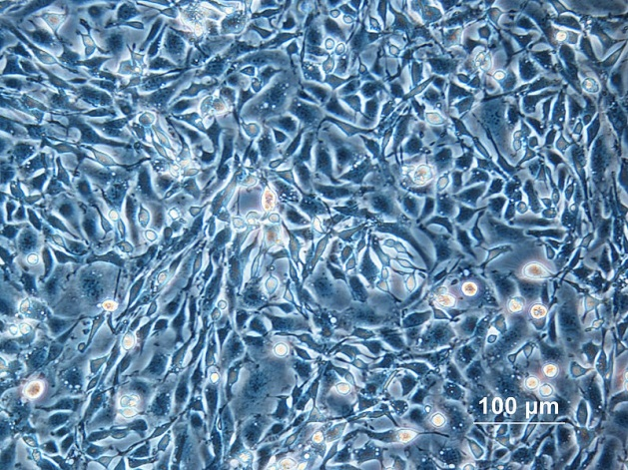
The refusal of law to countenance ownership of unchanged human tissue can lead to perverse outcomes, especially where the person from whom tissue is removed is not aware that it has been retained or used. This was the situation of both Henrietta Lacks and John Moore, Americans who had tissue removed from their bodies and immortalised as highly lucrative cell-lines used in medical research. Lack’s cells were removed from her tumour before she died in 1951 and were the first to be reproduced in an immortal cell line (see generally Skloot 2010). They were used in developing the polio vaccine and have been reproduced and used globally in research ever since. Public benefits, as well as large profits, were the result. Lack’s family were themselves unable to afford health insurance, and were unaware of the cell line for many years. John Moore also had cells taken in the course of treatment. A patent was granted over the resulting cell line, and his argument that his property had in effect been stolen from him was rejected by a court. The irony of both cases is that a person cannot own their own tissue, but once it is removed and altered, someone else can own it. The public may ultimately benefit, but so too do pharmaceutical and medical research companies.
Cell culture
Public Domain Image, Wikimedia Commons
It scarcely needs mentioning, as these examples illustrate, that the legally enforced dualism between persons and property is extensively corrupted in practice. Humanity often fails in its efforts to separate persons and property, and to value subjects over objects. Not only are subjects frequently commodified, but objects are personified and valued well over the least powerful humans. This is not always something we do individually, but is to be seen in cultural and practical slippage between persons and property. In addition to the examples mentioned, we can see this crossing over between persons and property in a variety of different ways. First, global trafficking networks illegally commodify people as manual labourers, sex workers, or adoptive children and the black market in organs is extensive (Budiani-Saberi and Delmonico 2008). Slavery is illegal, but any claim that it has been abolished is premature (Rassam 1999). Second, we are also accustomed to commodifying our own bodies, our own capabilities, achievements, and our personalities, as well as those of others. Third, there are objects, such as human DNA and body parts which we may see as personal, but which are also capable of being objectified. And finally, we frequently and quite legitimately invest objects with some personal, cultural, national or spiritual significance. The object is more than simply a thing, but becomes rather a thing of special meaning and is perhaps even invested with its own subjectivity (see generally Davies 2007: 77-81).
Part of the complexity here is that the terminology of property is both compelling and dynamic – it is easy to imagine ownership of all types of things, and the semantic shift from having power over something to owning it is relatively slight. Discourse around property is highly adaptable. In a recent South Australian case a man was charged with abducting his own children. In his defence, he claimed that the family court order giving custody to his ex partner was invalid because he had a prior ‘copyright’ claim. He stated
for a start the children are copyrighted, which means they are dramatic work produced by using skill . . . the mother then entrusted me further than that, having me put my surname on them as a trademark which gives me the ultimate say what’s going on with them, until they turned 18 . . .. Everything that has been happening with them is an unlawful breach of that . . .
Although this claim is, as the judge said, ‘plainly absurd’, using the language of property in such a context is in fact imaginable or thinkable. After all, the South Australian criminal legislation does refer specifically to the ‘right to possession of a child’ which itself sails close to conceptualising the child in proprietary terms.
In sum, although it broadly remains true that the person is the opposite of the commodity form, we can see that people and things are not entirely separate, but rather circulate in a vast economy of commodified persons and personified objects. This looks like an impasse or contradiction which needs clearing up, but it is in fact explained by the relational nature of persons and property – that they are constituted within social, legal and symbolic networks.
Persons and Property
This leads me to the second half of Frow’s statement, that the person is the condition of existence for the commodity or property form, a claim which has several quite different meanings. First, to state the obvious, persons are the precondition for property because the existence of property implies a subject who holds the legal rights and responsibilities of ownership.
Second, there is an etymological connection between the word property and an idea of the self – the word property is related to terms such as proper, propriety, and appropriate. This is more evident in other languages than it is in English, but one archaic sense of the term proper designates something connected to the self – just as we might refer now to a person as their ‘own woman’ meaning that she is independent, or say that she has her own objectives, in the past the term proper might have been used in such contexts. Both the terms ‘own’ and ‘proper’ refer to that which is particular to a person, and are connected to property as things which we own. The semantic connections are fascinating and extensive – again to quote Gray, a ‘powerful network of nuances’ (2010: 194; see also Davies 2007: 25-27), but there is not time to explore it fully.
A third connection between property and the person comes from philosophy. Best known in this context is John Locke who, as I have said, stated that ‘every man has a property in his own person’. This claim negates the possibility of slavery, but it also connects the person with property by stating that we own ourselves. JW Harris has called this a ‘spectacular non sequitur’ since it clearly does not follow from the fact that we are not owned by others that we therefore own ourselves (Harris 1996: 71). The idea presumes that everything must be either persons or property and implies that we are both subject and object to ourselves. Regardless of these logical difficulties, the image of the person as a self-owner – or the ‘liberal notion of possessive individualism’ as MacPherson termed it (1964) – is profoundly embedded in liberal thought – it is the image of self-determination, of having basic control and power over ourselves, and only surrendering part of this power in exchange for other benefits, such as the protection of the state, or remunerated employment.
This is a deeply individualistic notion of the person – it involves the idea that the person is quintessentially an owner; that we do actually own ourselves as well as a selection of the things around us; and that the person is, metaphorically at least, what Jennifer Nedelsky called a ‘bounded self’ or a person defined by their boundaries and self-containment (Nedelsky 1990). We are all self contained and autonomous.
Such an image of the self may appear to be available to both women and men, and regardless of race or heritage. However, it is a metaphor of the self which has historically been very strongly associated with masculine and white identity. Women have been more likely to be seen as unbounded: as relational selves and carers (Nedelsky 1990: 170; Naffine 1998), while Aboriginal people in Australia were typically regarded as non-owners and not the subject of rights. In the context of the United States, Cheryl Harris has argued that whiteness itself is a kind of self-owned property, and that this is a symbolic effect of slavery, which divided people along racial lines of self-owner and chattel (1993). Although the formal dehumanisation has now been remedied, when it comes to symbolic relations, these images of the person are still quite strong: it remains the white male who is typified as the normative owner, self-owner, and subject of rights, while others occupy the position of objects and can struggle to be visible as rights bearers. It is no surprise that this symbolism about who is an owner is reflected in reality, where gendered and racial distributions of property are well known.
Beverley Skeggs argues that possessive individualism remains strong in popular understandings of personal identity. We are formed as social beings by the acquisition of cultural property. As she says,
. . . some activities, practices and dispositions can enhance the overall value of personhood: an example of which would be the cultural education of the middle class child who is taken to galleries, museums, ballet, music lessons, etc, activities which are all assumed to be morally ‘good’ for the person but which will also have an exchange value in later life as the cultural capital necessary for employability and social networking. (2004: 75)
We can see from this that the reverse of Frow’s statement also rings true, that is, not only is the person the condition of existence of property, but property is the condition of existence of the form of the person. We become defined in part by those cultural attributes which we have acquired as a kind of personal property or value.
Locke’s statement about self-ownership is not only the basis for this extensive and very problematic Western liberal notion of selfhood, it is also the basis for owning other things, besides ourselves. As is well known, Locke goes on to argue that since we own ourselves and our labour, whenever we work on something we transform it so that it is connected to us – Locke says that if we take something out of the state of nature and change it, we have a natural right to it. In the contemporary context this might serve as a partial justification for copyright, patents, and other forms of intellectual property which are the result of creativity. It might also serve as justification for our labour-based earnings and anything we have purchased with those earnings. But it is slim if any justification for inherited property, or profits based on the labour of others, or investment profits. Locke’s natural law justification served for an era of colonial expansion where the labours of indigenous peoples went unrecognised and their connection to land was seen as arbitrary, especially where they lived relatively mobile lives (Arneil 1994 and 1996; Tully 1993; Parekh 1995). In consequence, appropriating the land by fencing and agriculture was seen as a legitimate taking of terra nullius, or land belonging to no-one. Ironically, non-indigenous people are now beginning to understand the depths of indigenous connections with land, and the limitations of the more exploitative relationship toward land which has characterised most of Western history (see Watson 1997).
We can see therefore that there are several powerful connections in Western language and philosophy between property and the person. Most significantly, we are often said to be self-owners in a social and cultural sense, even if there is no legal basis for this; property acts as a kind of metaphor for an independent person, the bounded self; and property ownership is sometimes said to be justified by the natural right that people have to their own labour and products. The person-property relation operates not only to connect persons to things, but also to define the self, to justify ownership, to delineate private from public, and to organise society.
3. Law Moving On
As I indicated at the outset, property has long been understood by legal theorists to be socially constructed and based on the relationships between people. However, because of the philosophical ties to individualism, a pervasive view of property has emphasised the priority of individual rights over broader cultural and community interests. This view of property crosses both legal and everyday uses, and is in some ways encouraged by the adaptability of property discourse which I mentioned earlier.
For some time, however, there has been what might optimistically be called the beginnings of a paradigm shift in the meanings and extent of property and its ties to individualism and liberalism. You would not perhaps instinctively or even reflectively think this, looking around at the excesses of modern capitalism, the culture of accumulation, the detachment of individuals from physical communities, the extremes of individual wealth, and the disproportionate value and political power which we still allow to people who have the cultural capital of their race, gender and ownership status. Perhaps what looks to be a paradigm shift is in fact only an eleventh-hour reaction to these excesses.
Nonetheless, I think it is possible to discern in law, in scholarship, and in many forms of activism, some pressures and changes to the idea of the person, to the idea of property, and the ways in which they relate. Increasingly, we see the values of community, environment, and the future reflected in this discourse and indeed in the law. It is true that these are very imperfect and piecemeal changes, which do not begin to address fundamental matters such as the continuing dispossession of indigenous peoples around the world or the extreme inequality which ownership regimes produce. It will moreover doubtless take decades or longer for these to solidify into any substantial change in the form of liberal property regimes, but I think such a change is possible.
To begin with the person, the ideology of the liberal bounded and autonomous self has been challenged by a more relational idea of the person. Certainly this is true in legal scholarship, where feminist commentators have for some decades criticised and reconstructed notions of the person which are based solely on the model of the rational self-determining individual. As Moira Gatens, for instance, says – ‘for an individual to endure requires exchange, struggle, and co-operation with other individuals’ (quoted in Strathern 2005: 30). And in the context of property, Jennifer Nedelsky, argued some years ago that the boundary metaphor produces an impoverished and politically inappropriate notion of the person, a person who is separated from their communities and which suppresses the role of relationships in the formation of the self. She argued that this person should be rethought in favour of a connected conception of the person which would not, however, be defined by the traditional gender stereotypes (Nedelsky 1990; see also Nedelsky 2011). This does not necessarily mean eliminating the values of rationality and autonomy, but simply putting them into a balance with relationality and context.

When we look at property, we also see a heightened concern for the relationships within which property is situated. This is evidenced by a variety of debates focused on the idea of the commons. Promotion of commonly owned resources has in the past been hampered by the orthodoxy of the ‘tragedy of the commons’ that is, the notion that such resources will over time necessarily be degraded and wasted, because of the incentives for an individual to overuse the resource. However, in 2009 Elinor Ostrom was awarded the Nobel Memorial Prize in Economics, in recognition of her work on the commons. Ostrom’s work, undertaken in collaboration with many others, challenged the ‘tragedy of the commons’ narrative, by providing a more nuanced account which showed that well managed common resources such as fisheries, or commonly-held forests and pastures, are not necessarily wasted over time (see eg Ostrom et al 1999). Under certain conditions, including extensive co-operation among users and the development of elaborate management principles, such resources can be more efficiently managed than private resources (Ostrom 2010).
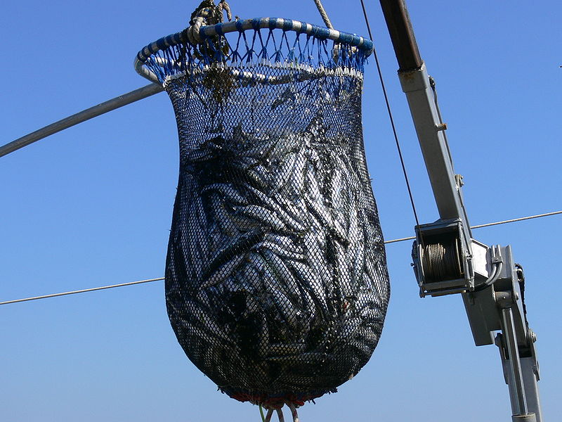
Ostrom’s award is I think a symptom of the current awareness of the importance of shared resources for social well-being. Numerous property law scholars over the past decade have turned their attention to urban, rural and global commons, to the public intellectual domain, and to the environment (Holder and Flessas 2008; Alexander and Peñalver 2009; Milun 2010). This interest has resulted in contemporary notions of property in which individual rights and private sphere interests are only part of a more complex picture where the interests of a multitude of communities as well as social obligations and environmental imperatives are part of the discourse relating to all types of resource. The resources in question are many, ranging from scientific knowledge, to rights of way over land, to heritage, and the internet. Just to give one of many possible examples, we can see this commitment to forms of community-oriented property in the construction of alternative licenses which are now available for distribution of intellectual property – most of the images used in this paper for instance, could be the subject of copyright (meaning there would be a need to seek permission and possibly pay a fee to use them). However, their owners have released them into the public domain or published them under some form of creative commons license which bypasses copyright law – they are freely available, usually with attribution. The internet provides many examples of conflict between open and proprietorial modes: Wikipedia, for instance, recently blacked out its English-language website in protest at proposed US legislation for strengthening copyright enforcement which they say poses a threat to the free and open internet.
Property and the commons
(Image by F Lamiot: Creative Commons Attribution-Share Alike 3.0 License. Wikimedia Commons)
This re-valuing of community is not confined to activism, symbolism, or the internet. Law itself has arguably been moving in this direction for some decades, as environmental, heritage, and planning regulations have been strengthened. Layers of regulation can be regarded as subtractions from an otherwise fixed notion of property, as interference by the state in our private things and selves (see eg Gray 2007). However, it is more productive and arguably more accurate to regard such regulation as evidence of an alternative conception of property which is intrinsic to law. Property law is not only about extensive, durable and exclusive individual ownership as the basis for social order, but also incorporates more fragile, contextual, and limited use-rights which are highly regulated, held at the discretion of the state and which can be withdrawn for social and environmental purposes. Two decades ago, Eric Freyfogle predicted that water law – which is more about use of a scarce resource than ownership of it – was the leading edge of property. He said,
If property law does develop like water law, it will increasingly exist as a collection of use-rights, rights defined in specific contexts and in terms of similar rights held by other people. Property use entitlements will be phrased in terms of responsibilities and accommodations rather than rights and autonomy. (1989: 1531)
Echoing this thought, but describing it as reality some ten years later, Kevin Gray and Susan Francis Gray wrote in relation to land law that it ‘may well denote no more than a temporarily licensed form of utility or user privilege which may be extended, varied, or withdrawn at the sole discretion of the state’ (quoted in Underkuffler 2003: 3). As Gray says, ‘Property ... is organic, interactive, socially defined, normatively resilient, and extremely relative’ (2010: 192-193). Even when it is focused exclusively on law, contemporary property scholarship often emphasises the contingency and the complexity of property, rather than its solidity and durability.
As part of this rebalancing of rights with responsibilities, for instance, property in land is now sometimes imagined through the language of stewardship or custodianship (Karp 1993; Lucy and Mitchell 1996). Stewardship implies that an owner holds a duty to current and future users of a resource, and in a sense, a duty to the resource itself. Stewardship has not been explicitly recognised as a facet of property, though it is making its way into various areas of law which deal with the environment. Extensive regulation dealing with maintenance and improvement of land quality, permissible land uses, recycling of resources, licensing for mining and clearance of vegetation, alteration of buildings and so forth, mean that responsibility to the future is already a prominent feature of law.
Another way of bringing the value of community into the discourse of property has been suggested by Davina Cooper in her discussion of belonging. Cooper points out that ‘belonging’ is not only about control over an object, such as the things that belong to me in the sense that I own them, but is also ‘a relationship of connection, of part to whole’ (Cooper 2007: 629; cf Keenan 2010): in this sense, a person belongs to a family, not because they are owned by the family, but because they are connected to it, ‘part to whole’. Belonging in this sense engenders an idea of property in which connection and relationship are central. Property is about belonging, meaning that community fabric is as important as individual security in understanding it.
4. Concluding Thoughts
Generally therefore, recent scholarship has seen the development of a more complex notion of the person as well as a greater emphasis upon the community and environmental imperatives underlying the definition of property rights. In conclusion, I would just like to make a few comments about how these altered conceptions of persons and property are linked.
First, we are moving away from an imaginary based on boundaries, self-containment and control, to a consciousness which is relational, contextual, and deeply social. The strong nexus between persons and property must now be seen as mediated by values associated with the commons, the public domain, and the numerous communities within which we find ourselves. It is simply no longer possible to remove shared interests from questions of identity and ownership.
Second, thinking about property and persons relationally means that the image of the quintessential owner shifts from isolated and powerful individuals, to connected individuals, groups, and even marginalised people (van der Walt 2010). The development of native title in Australia, for instance, is based on groups as the relevant interest bearers (a conceptual shift which remains, nonetheless, inherently deficient in practice).
Third, we can also see a different approach to the ever-present issue of distributional justice: in addition to thinking about who owns and how much, distributional issues can also be defined internally to property – that is, in relation to something which I own, what is the distribution of property rights between me and the community? Instead of simply thinking about shifting property around between people, we are beginning to shift and rebalance what property means in different contexts. The flexibility of property discourse can facilitate this change.
Fourth, it is not possible in this or any other context to speak of a single undifferentiated community. Communities are obviously multiple, contingent and dynamic. It is therefore not possible to formulate general principles about property and persons which will hold for all situations.
And finally, persons and property are artificial legal constructs the meaning of which cannot be governed by law alone. They circulate through many layers of social relationships and networks. They constitute and are produced by material and symbolic economies. Uncovering a few threads in these relationships begs a multitude of questions about others.

References
Alexander, G and Peñalver, E eds (2009) Property and Community New York: OUP

Arneil, B (1994) ‘Trade, Plantations, and Property: John Locke and the Economic Defense of Colonialism’ Journal of the History of Ideas 55: 591-609

Arneil, B (1996) John Locke and America: The Defence of English Colonialism Oxford: Clarendon Press

Bottomley, A (2007) ‘A Trip to the Mall: Revisiting the Public/Private Divide’ in H Lim and A Bottomley eds Feminist Perspectives on Land Law Abingdon: Routledge-Cavendish

Budiani-Saberi, BA and Delmonico, FL (2008) ‘Organ Trafficking and Transplant Tourism: A Comment on the Global Realities’ American Journal of Transplantation 8: 925-929

Chambers, R (2001) An Introduction to Property Law in Australia Sydney: LBC Information Services

Cohen, M (1927) ‘Property and Sovereignty’ Cornell Law Quarterly 13: 8-30.

Cooper, D (2007) ‘Opening up Ownership: Community Belonging, Belongings, and the Productive Life of Property’ Law and Social Inquiry 32: 625-664

Davies, M (2007) Property: Meanings, Histories, Theories London: Routledge-Cavendish

Davies, M and Naffine, N (2001) Are Persons Property? Legal Debates About Property and Personality Aldershot: Ashgate

Francione, G (2008) Animals as Persons: Essays on the Abolition of Animal Exploitation New York: Columbia University Press

Freyfogle, E (1989) ‘Context and Accommodation in Modern Property Law’ Stanford Law Review 41: 1529-1556

Frow, J (1997) Time and Commodity Culture: Essays in Cultural Theory and Postmodernity Oxford: OUP

Gray K (1991) ‘Property in Thin Air’ Cambridge Law Journal 50: 252-307
Gray K (2007) ‘Can Environmental Regulation Constitute a Taking of Property at Common Law?’ Environment and Planning Law Journal 24: 161-182
Gray, K (2010) ‘Property in a Queue’ in G Alexander and E Peñalver eds Property and Community Oxford: OUP
Gray, K and Gray, SF (1999) ‘Private Property and Public Propriety’ in J McLean ed Property and the Constitution Oxford: Hart

Grey, T (1980) ‘The Disintegration of Property’ Nomos 22: 69-85
Hamilton, S (2009) Impersonations: Troubling the Person in Law and Culture Toronto: University of Toronto Press
Hardcastle, R (2007) Law and the Human Body: Property Rights, Ownership and Control Oxford: Hart Publishing
Harris, C (1993) ‘Whiteness as Property’ Harvard Law Review 106: 1707-1791

Harris, JW (1996) ‘Who Owns My Body?’ Oxford Journal of Legal Studies 16: 55-84

Hohfeld, WN (1913) ‘Some Fundamental Legal Conceptions as Applied in Judicial Reasoning’ Yale Law Journal 23: 16, 28-59

Hohfeld, WN (1917) ‘Fundamental Legal Conceptions as Applied in Judicial Reasoning’ Yale Law Journal 26: 710-770

Holder, J and Flessas, T (2008) ‘Emerging Commons’ Social and Legal Studies 17: 299-310

Honoré, AM (1961) ‘Ownership’ in AG Guest ed Oxford Essays in Jurisprudence London: OUP

Kant, I (1988) ‘Foundations of the Metaphysics of Morals’ in L White Beck ed Kant: Selection New York: Macmillan

Karp, J (1993) ‘A Private Property Duty of Stewardship: Changing our Land Ethic’ Environmental Law 23: 735-762

Keenan, S (2010) ‘Subversive Property: Reshaping Malleable Spaces of Belonging’ Social and Legal Studies 19: 424-439

Layard, A (2010) ‘Shopping in the Public Realm: The Law of Place’ Journal of Law and Society 37: 412-441

Locke, J (1988) Two Treatises on Government (first published in 1690) P Laslett ed, Cambridge: Cambridge University Press

Lucy, W and Mitchell, C (1996) ‘Replacing Private Property: The Case for Stewardship’ Cambridge Law Journal 55: 566-600

MacPherson, CB (1964) The Political Theory of Possessive Individualism: Hobbes to Locke Oxford: Clarendon Press

McHale, J (2000) ‘Waste, Ownership and Bodily Products’ Health Care Analysis 8: 123-135

Milun, K (2010) The Political Uncommons: The Cross Cultural Logic of the Global Commons Farnham: Ashgate

Naffine, N (1998) ‘The Legal Structure of Self-Ownership: Or the Self-Possessed Man and the Woman Possessed’ Journal of Law and Society 25: 193-212

Naffine N (2003) ‘Who Are Law’s Persons? From Cheshire Cats to Responsible Subjects’ Modern Law Review 66: 346-367
Nedelsky, J (1990) ‘Law, Boundaries, and the Bounded Self ‘ Representations 30: 162-189

Nedelsky, J (2011) Law’s Relations: A Relational Theory of Self, Autonomy, and Law New York: OUP

Ostrom, E, Burger, J, Field, C, Norgaard, R, and Policansky, D (1999) ‘Revisiting the Commons: Local Lessons, Global Challenges’ Science 284 (9 April): 278-282

Ostrom, E (2010) ‘Beyond Markets and States: Polycentric Governance of Complex Economic Systems’ American Economic Review 100: 641-672

Parekh, B (1995) ‘Liberalism and Colonialism: A Critique of Locke and Mill’ in J Nederveen Pieterse and B Parekh eds The Decolonization of the Imagination: Culture, Knowledge and Power New Jersey: Zed Books

Rassam, AY (1999) ‘Contemporary Forms of Slavery and the Evolution of the Prohibition of Slavery and the Slave Trade Under Customary International Law’ Virginia Journal of International Law 39: 303-352

Skene, L (2009) ‘Should Women be Paid for Donating their Eggs for Human Embryo Research?’ Monash Bioethics Review 28(4): 28.1-28.8
Skeggs, B (2004) ‘Exchange, Value and Affect: Bourdieu and “the Self” ’ Sociological Review 52 (Supplementary Issue 2): 75-95

Skloot, R (2010) The Immortal Life of Henrietta Lacks New York: Crown Publishing
Strathern M (2005) Kinship, Law and the Unexpected: Relatives are Always a Surprise Cambridge: Cambridge University Press
Tully, J (1993) An Approach to Political Philosophy: Locke in Contexts Cambridge: Cambridge University Press

Tur R (1987) ‘The “Person” in Law’ in A Peacocke and G Gillett eds Persons and Personality: A Contemporary Inquiry Oxford: Basil Blackwell
Underkuffler, L (2010) The Idea of Property: Its Meaning and Power Oxford: OUP
Van der Walt, AJ (2010) ‘Property and Marginality’ in G Alexander and E Peñalver eds Property and Community Oxford: OUP
Watson, I (1997), ‘Indigenous Peoples’ Law-Ways: Survival Against the Colonial State’ Australian Feminist Law Journal 8: 39-58

* Professor of Law, Flinders University. margaret.davies@flinders.edu.au. This article is an edited version of a Leverhulme Public Lecture delivered at the University of Kent on 18 January, 2012. My thanks go to the Leverhulme Trust for funding my visit to the UK, to the University of Kent for organising the lecture and the Kent Law School, in particular the Centre for Law, Gender and Sexuality, for hosting my visit.
Yanner v Eaton (1999) 201 CLR 351-413
See eg. Philip Morris v Commonwealth of Australia [2012] HCA Trans 46 (27 February 2012)
‘Breast Milk Ice-Cream Goes on Sale in Covent Garden’ BBC, 24 February 2011 http://www.bbc.co.uk/news/uk-england-london-12569011 (viewed 6 March 2012)
Moore v Regents of the University of California (1990) 793 P 2d 479.
R v Breur [2011] SADC 184, para 44.
Criminal Law Consolidation Act 1935, s80(2).
Although Hegel’s Philosophy of Right also constructs a significant narrative about the connection between property and the person, I do not deal with it here. See generally Davies 2007: 96-107.
See http://wikimediafoundation.org/wiki/English_Wikipedia_anti-SOPA_blackout
See, for instance, in the Australian context, the Product Stewardship Act 2011; The Product Stewardship (Oil) Act 2000; the Environment Protection and Biodiversity Conservation Act 1999, s 3A; and the Environmental Stewardship Program (http://www.nrm.gov.au/funding/stewardship/index.html).

