**ADRIAN EVANS - CONTRIBUTION TO CLINICAL PEDAGOGY AND GLOBAL JUSTICE**

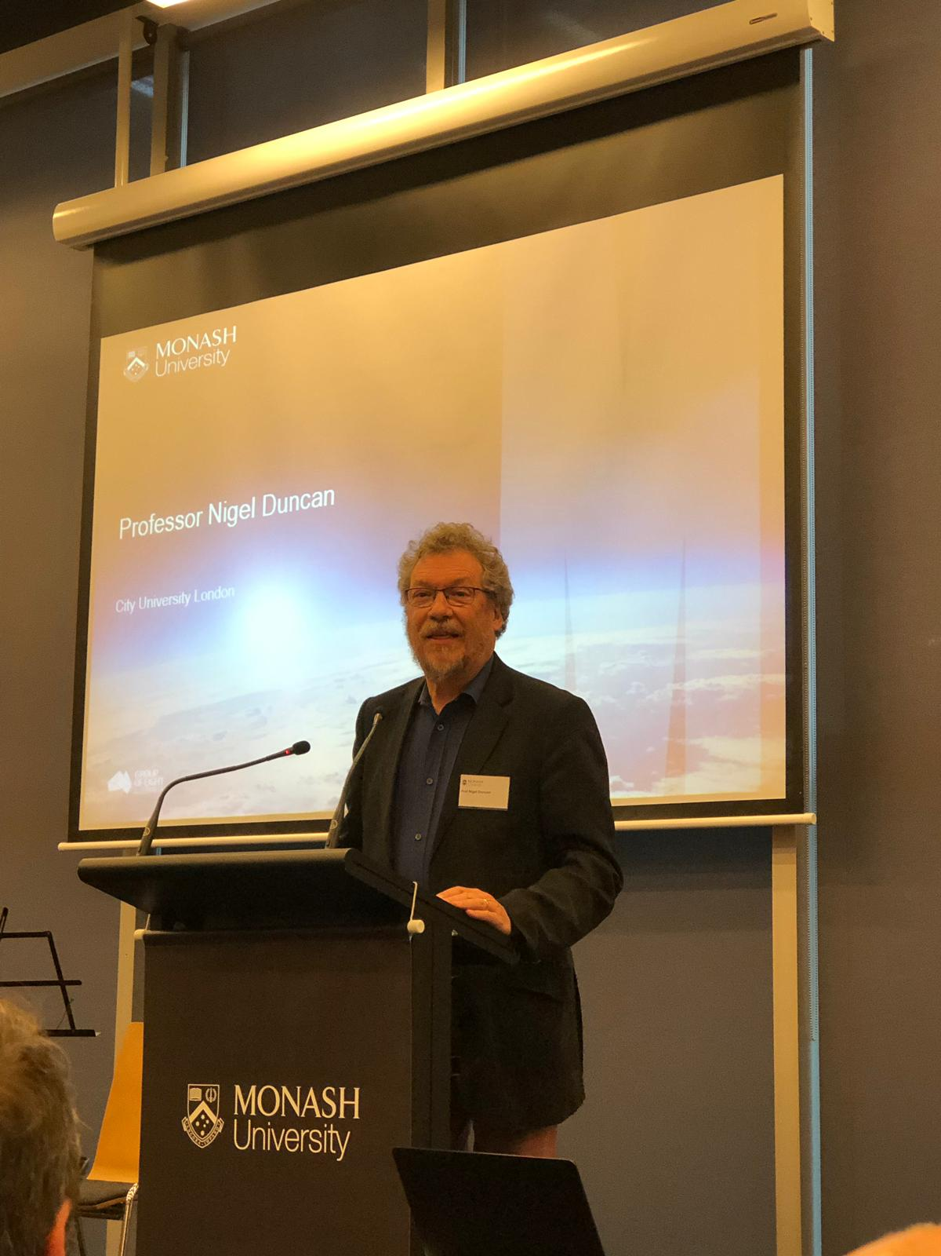**Professor Nigel Duncan,**

**City Law School, UK**

It is a great privilege to be asked to say a little about Adrian’s work. I have been asked to address his contribution to clinical pedagogy and global justice. Such is the way in which he has integrated different aspects of his work so that each informs the other, it has been hard for each speaker to separate out their allocated topics. In that attempt I shall firstly address Adrian’s contribution to the developing clinical pedagogy of the United Kingdom, as that is what I know best. I shall then turn to address his contribution to global justice through a wonderful project we have both worked on: the Global Alliance for Justice Education.



I first met Adrian in the mid 1990s when he was visiting the UK to attend a clinic conference I was involved in organising. One of the characteristics of spending time with Adrian is that we get to walk in beautiful places. At this conference, which was the brainchild of Richard Grimes, we concluded it by going walking in the Peak District. We talked about all sorts of things, but what I most remember is discussing his values research with Adrian. This led to his publications with Josephine Palermo . We had hoped to develop a parallel study in the UK, but were unable to get the funding to support it. However, that combination of discussions of working with students in clinic and the values we bring to teaching learning and practice have characterised all my work with Adrian.

His main contribution to clinical pedagogy in the UK has been through his writing, and I will take you through the main pieces.

Hugh Brayne, Richard Grimes and I, having founded the UK Clinical Legal Education Organisation, began working on a book designed to encourage and advise colleagues considering setting up clinical programmes in the UK. We sought the advice of several colleagues with specific experience to inform what we wrote and to write their own sections. The book was published by the Blackstone Press in 1998. Adrian wrote a chapter: ‘The Australian Perspective’. This was not simply a presentation of what had been learned in Australia, but was critical of a lot of what we said. We had explored the question of whether it was right for a clinic to choose cases in order to provide students with specific experience that was most useful to their learning needs at that time. We had suggested that whether or not that was legitimate might depend on where the funding for the colonic had come from (an argument which now feels uncomfortably market-oriented to me). Adrian addressed this head on, focussing on the values and mission of the clinic and criticising those that prioritise student experience over client needs. This has led to a significant debate since. Adrian’s arguments anticipated the later critique of Donald Nicolson: if we tell students that the clients are there to help them learn we foster an attitude that the client is there for them, rather than they being there for the client – which they risk taking into practice. (Donald Nicolson, 2008, “’Education, Education, Education’: legal, moral and clinical”, 42:2 *The Law Teacher*, 145-172 at 169-70).

This article was published in a special issue on maintaining quality with a diminishing resource. In it Adrian argues the importance of developing a link between values and skills and that by working with external legal service agencies we can achieve this without adding to the cost of law school provision. One aspect of this article is worth flagging up as particularly characteristic of Adrian’s thinking. He introduces the idea of a spiritual element that (quoting Kirby J) may be missing.

This special issue was designed to respond to Roger Burridge and Julian Webb’s article in Legal Ethics “The Values of Common Law Legal Education: Rethinking Rules, Responsibilities, Relationships and Roles in the Law School”, (2007) 10(1) *Legal Ethics* 72-97. The special issue sought responses from three other commentators on legal education, Anthony Bradney, Fiona Cownie and Wesley Pue, whose arguments had been critiqued in that article. I also sought responses from Australia and the USA, and this was Adrian’s contribution. Again, he proposes live client clinic as a vector for helping students to develop awareness of their own values, comfort with diversity and the courage to act accordingly. He suggests what the appropriate values for legal practitioners are and gives practical guidance as to how to get students experiencing and thinking about these values.

Adrian’s final contribution to *The Law Teacher* was this article which appeared in the ‘Policy and Education Developments’ section of the journal. This reported on the project that culminated in the publication of the ‘Best Practices’ document, covering best practices in course design; law in context in a clinical setting; supervision; reflective student learning; assessment; staff; and infrastructure. The support given to this project by the Committee of Australian Law Deans is something that is sorely lacking in the UK, where circumstances are such that simple application of the recommendations will not be entirely effective. However, the subsequent publication of the book: Australian Clinical Legal Education: Designing and operating a best practice clinical program in an Australian law school by ANU Press, freely available to all as a pdf download, is an invaluable resource.

I will now turn to my second subject. In my view, Adrian’s major contribution to clinical pedagogy was his participation in the group that decided to set up an international organisation to promote ‘socially relevant legal education’ (Madhava Menon), bringing together law teachers and providers of legal services, especially to disadvantaged communities, for mutual benefit, and aiming to learn from all, not only the wealthy and privileged law schools.

This project arose out of a meeting in Florida which was intended to attract legal educators from around the world, but which in fact attracted very few. As a result it was decided to write to clinicians and others who were due to attend the Australasian Professional Legal Education Conference in Sydney in 1996. I was one of those who received a letter inviting us to a full day’s meeting before the start of the conference and Adrian was another. Some 20 of us met in Sydney, hosted by Simon Rice at the Centre for Legal Education, and thrashed out the basis for this organisation.

We were both then on the steering committee for the first conference which was to take place in India in 1999.

I have a very few pictures taken at that conference. This one shows Adrian presenting his paper during a plenary session. He and I also gave a joint paper at the first GAJE Conference, which took place in Thiravananthapuram in Kerala, India. One memorable experience happened in the main hall where our plenary sessions were held. This was a large building with open sides to allow a through breeze to make delegates more comfortable. Above us there were large cooling fans to keep the air in movement. The problem arose because above those fans were beams on which the local pigeons tended to congregate. I noticed that there were areas of the hall which people were avoiding. I assume that I do not need to be too explicit as we experienced the reality of a common and rather unpleasant saying.

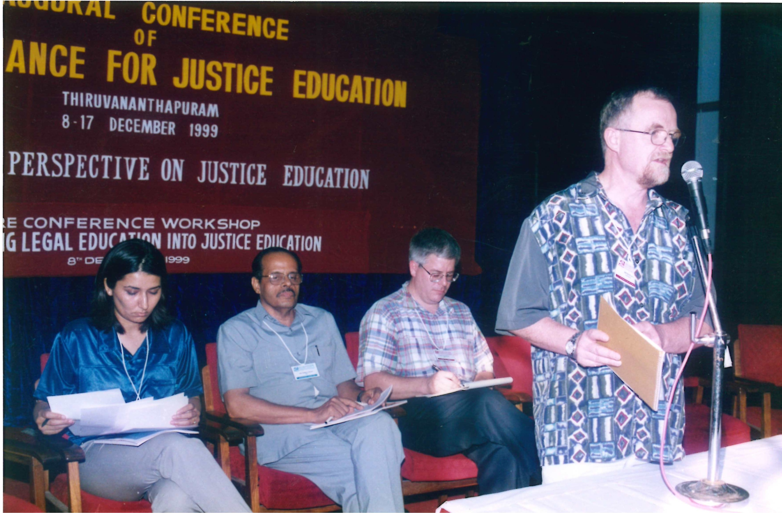

At this point I should explain something of the nature of a GAJE Conference. Typically they start with a one-day workshop on a significant theme to inform the work of the remainder of the conference. This is followed by a three- or four-day conference with academic papers and workshops, some in plenary but with many parallel sessions. Presenters are encouraged to ensure that their sessions are interactive and not simply the reading of an academic paper. The main conference is then followed by a series of ‘Train the Trainers’ workshops. At this first conference the Train the Trainers workshop started with an exploration of training in client counselling (interviewing) skills and then developed into the mentoring of individual projects by experienced clinical practitioners.

We did take some time off at the end of each day of the conference, and the beach at Kovalam was a short motor-rickshaw run away. Here we are taking a bit of rest and recreation.

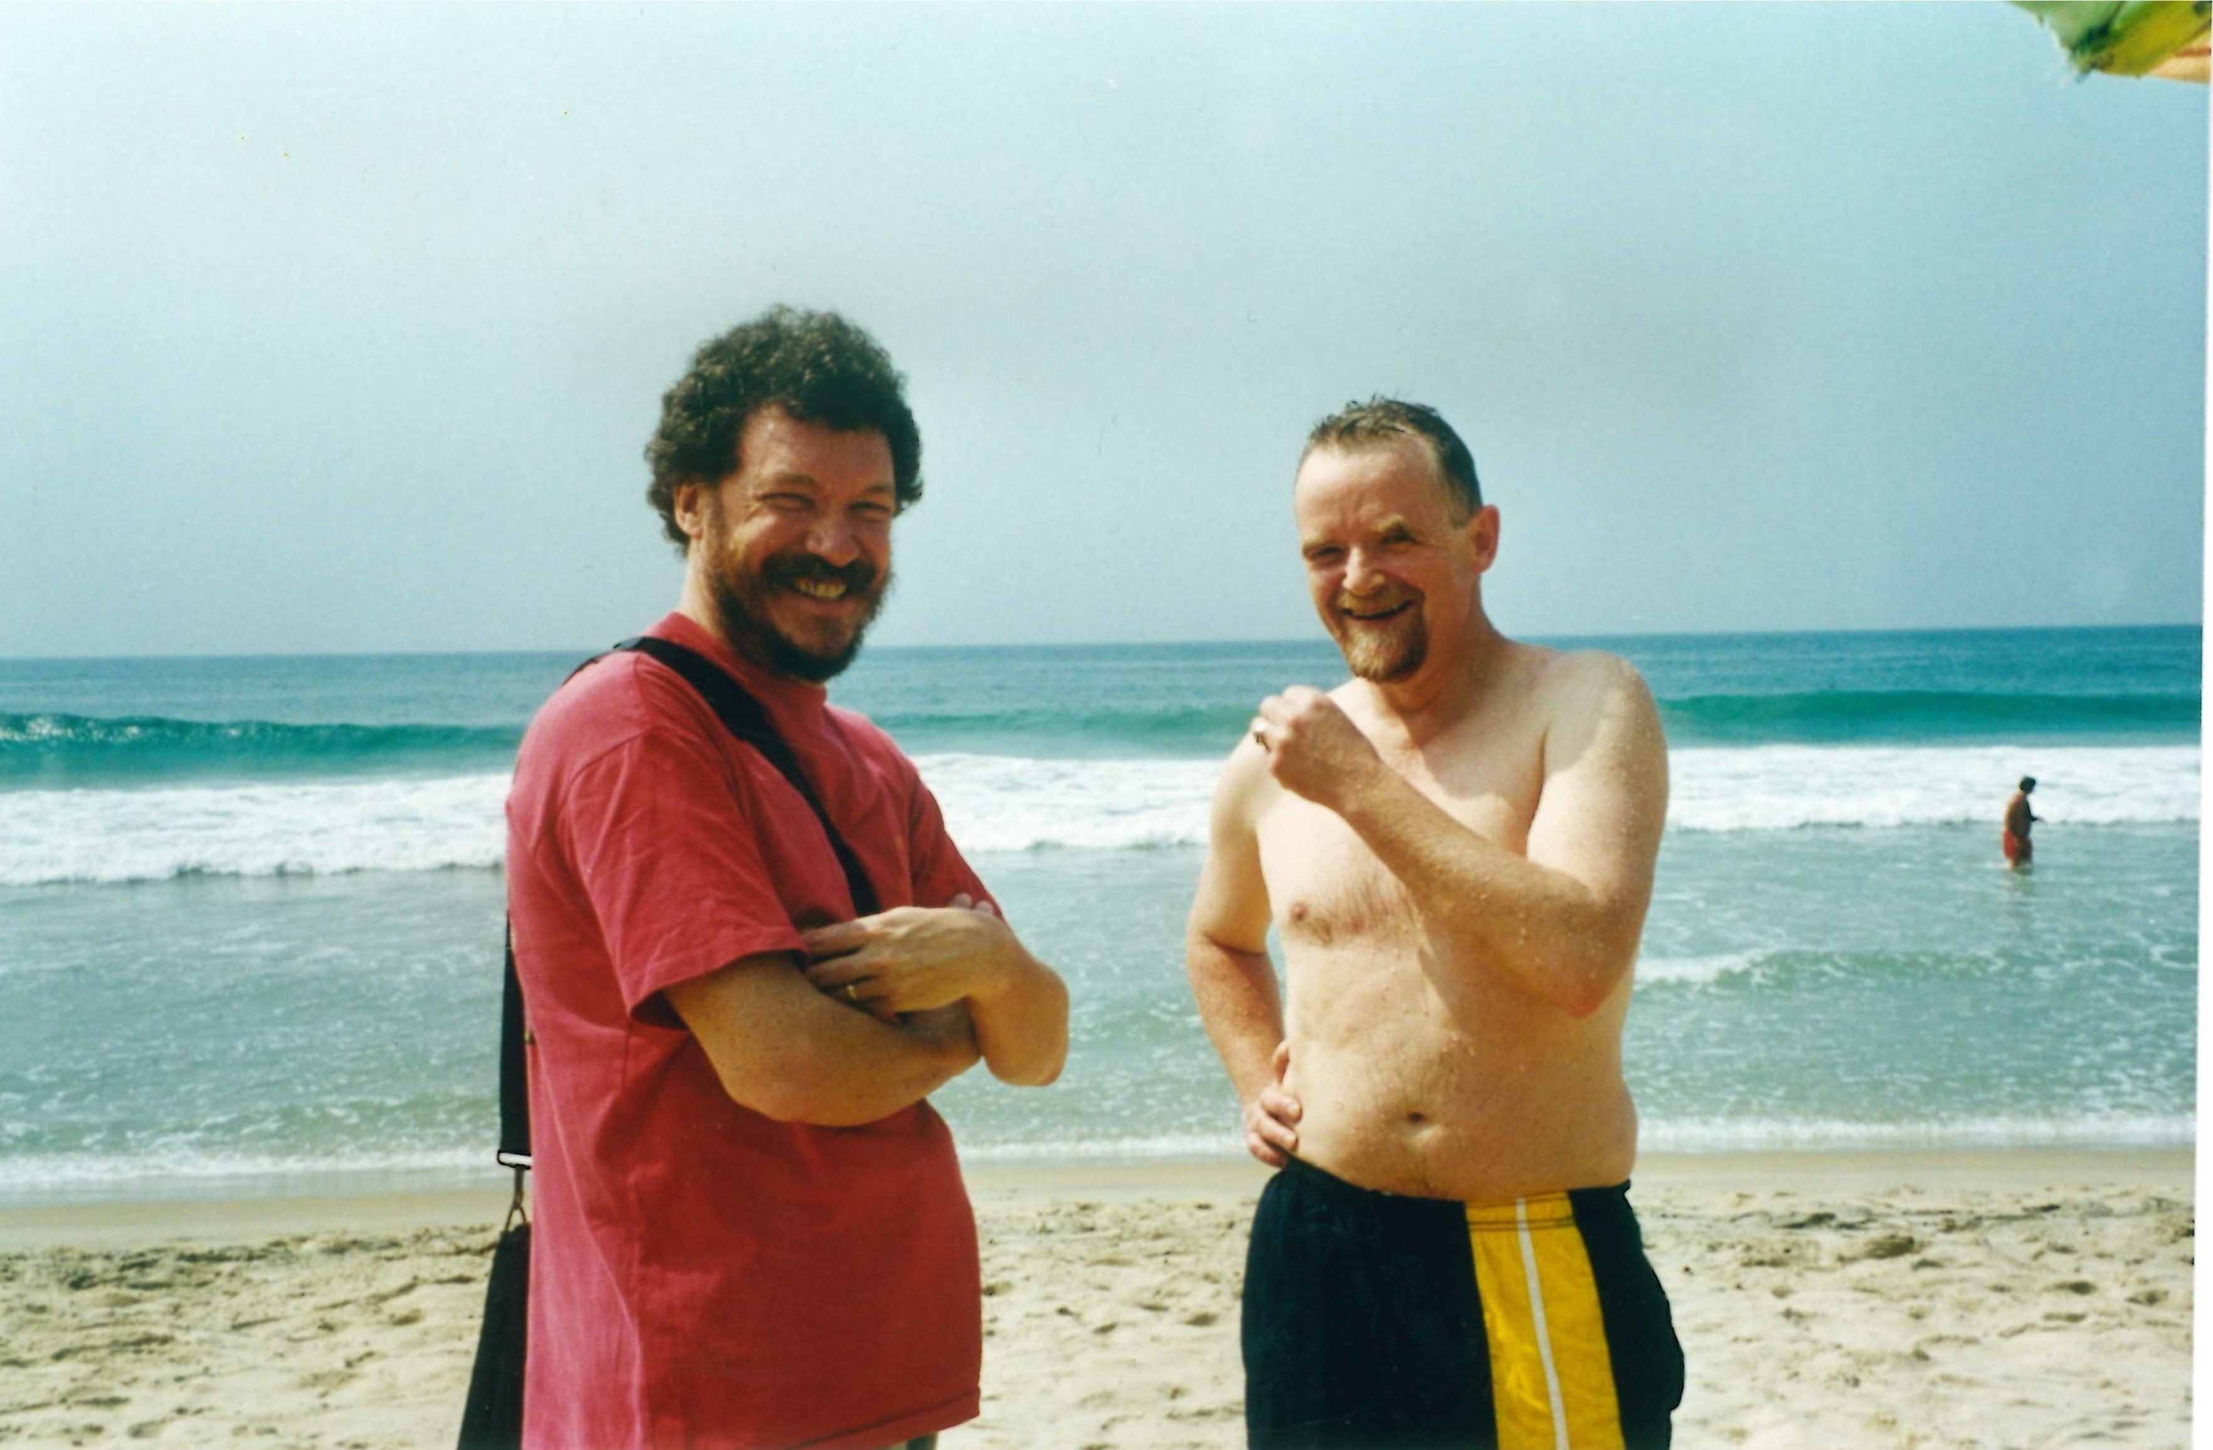

However, our intellectual debate continued. Those of you who have known Adrian for a while will have probably got the impression that his arguments are so good that he normally wins them. Well, sometimes he loses an argument and this is the result.



This photograph was taken in the apartment of Ela Gandhi, granddaughter of the Mahatma, an ANC MP for the area. This group of conference delegates were privileged to be invited for dinner there. She cooked us a wonderful spicy vegetarian meal, an experience I will never forget.

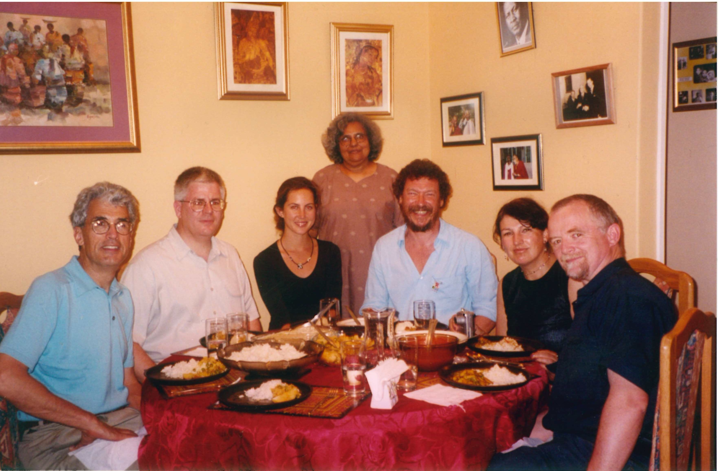

Adrian was heavily involved in the planning of this, the second GAJE Conference and the opening one-day workshop. This focussed on “Pervasive Justice Education in Law Schools and NGOs” and was prepared by Adrian, Neil Gold, Margaret Barry, Asha Ramgobin and David McQuoid Mason. The workshop was intended to explore the immediate issues and challenges of instilling justice education concepts and ambitions in law schools and NGOs and to work toward moving on from just meeting and discussing justice education to its implementation. The workshop began with a brief “morning contemplation” followed by an opening plenary session on “Introduction to Justice Education in the Curriculum” presented by Adrian Evans.

This opening workshop led to a session in the main conference: Mainstreaming Justice Education in the Law Curriculum.

Adrian was again involved in the planning for the third conference in Krakow. His specific contributions were as Pre-Conference workshop organiser with the themes: Curriculum for an ‘International Justice’ degree; and Strategies for formalising Justice Education.

This led into the theme of the main Conference: Teaching Values to Law Students, again a subject very close to Adrian’s heart.

The fourth conference took place in Cordoba, Argentina. Adrian had planned a session: “Legal Ethics Education as a Contribution to the Justice Mission of the Legal Profession”, but, in the end could not make it to the conference. I took over the running of a challenging workshop with design support from Sara Chandler (UK) and Clark Cunningham (USA). We had extra help from role playing participants: Julie Bishop (Australia); Richard Boswell (USA); Sally Hughes (UK).

In Manila in 2008 Adrian presented an interactive session: “Measuring a law school’s delivery of justice education”. This was designed to critique a proposed method for assessing whether a law school is a credible justice educator or not. A series of questions were proposed to participants, for example, ‘Is legal ethics a compulsory part of your law course?’ ‘How many school staff have a pro bono track record?’

This was designed to contribute to a chapter in Frank Bloch’s edited book which was subsequently published in 2011: *The Global Clinical Movement: Educating Lawyers for Social Justice,* OUP.

Subsequently GAJE has continued to thrive. I have been fortunate enough to attend the Valencia, Eskisehir and Puebla conferences and they continue to have the same challenging and exciting spirit and are a great, welcoming opportunity for new and experienced clinicians to meet each other and the providers of legal services to disadvantaged communities across the world. I recommend the next conference in Bandung, Indonesia to you.

I started with a picture of a walk with Adrian so I’ll finish my section with another – this one more local to us here in Melbourne – down on Wilson’s Prom. This is Oberon Bay, taken through the branches of tea trees blackened by a major fire earlier in the year.

This picture was taken by Peter Joy, to whom I now hand over.

