Copyright Transfer Agreement Form
(Please sign and attach this form in the supplementary file when you make a new submission)
I, the undersigned:

Full Name | : Wildan Munawar
Affiliation | : Universitas Djuanda
Active Email | : wildan.munawar@unida.ac.id
Address | : Jalan tol ciawi no 1 Kotak Pos 35 Ciawi Bogor 16720
Phone Number | : 085715222529
Title of Submitted Article | : Islamic Economics and Politico-Legal Policy; Defining The Fundamental Role of Government In Creating Prudential Business System
List of Authors | : Abdillah, Ali Ridho, JM.Muslimin, Wildan Munawar

declare that the article above that:
- The submission has not been previously published, nor is it before another journal for consideration or currently not in the process of other journal publications.
- There is no conflict of interest between the authors.
- The submission is original, not translated.
- I am willing to be responsible if there are parties who feel disadvantaged privately and/or based on a lawsuit in the future by the publication of this article.

I also declare that any and all rights in and to the article including, without limitation, all copyrights are transferred to International Journal of Islamic Economics and Finance (IJIEF). Therefore, the copyright transfer hands it the power and authority to edit, reproduce, distribute copies, and to publish the article partly or fully.

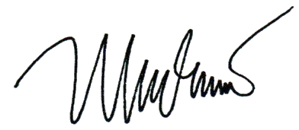
Bogor, 15 November 2022

______________________________________________
Wildan Munawar

